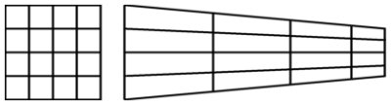

What I have done here is: I have drawn a bicycle and the grids of squares behind the bicycle represent the size of the bicycle. At the moment I’m looking at the bicycle from the front view
Now using my math knowledge, perspective drawing if I looked at the bicycle from a corner (corner at the right)

The grid of the bicycle will look like this when looking at it from the corner

If I drew this by hand I will look at every square of the grid and use the help of that to draw the bicycle (when looking at it from the right corner) like looking through a window

It also brings in the idea of stretching an image and enlarging the image by a scale factor when looking at the image from a particular vantage point

