Firstly, I constructed a table, similar to the one shown below, to help mark and track which numbers satisfy the rule of the different lights.

 | 0 | 1 | 2 | 3 | 4 | 5 | 6 | 7 | 8 | 9 | 10 | 11 | 12 | 13 | 14 | 15 | 16 | 17 | 18 | 19 | 20
Yellow |  |  | X |  |  |  |  |  |  |  |  | X |  |  |  |  |  |  |  |  | X
Red | X |  |  | X |  |  | X |  |  | X |  |  | X |  |  | X |  |  | X
Green |  |  | X |  |  | X |  |  | X |  |  | X |  |  | X |  |  | X |  |  | X
Blue |  | X |  |  |  |  |  |  |  |  |  |  | X

Then, I wrote out the sequences for each light.
For example,
Level 1 Yellow: 2,11,20,29…
We can notice that the sequence starts with 2 and 9 is added each time to find the next number. To generate a mathematical rule for this,
I found the nth term of the sequence. This enables us to acquire the terms in the sequence without using the machine.

The common difference (number the sequence goes up in) of the sequence is 9, and this can be found by subtracting any one term by the previous term (e.g. 11-2 or 20-11).
I used this to find the ‘0th term’ (the term preceding the 1st term) by subtracting the 9 from the first term, giving -7.

Therefore, the nth term of the sequence is 9n-7. This tells us that the sequence is arithmetic and 9 is added each time to find the next term.

We can then substitute the term positions to determine other numbers in the sequence.
9(1)-7 = 2
9(2)-7 = 11
9(3)-7 = 20
9(4)-7=29
9(5)-7 = 38…
These are the numbers for which the lightbulb would switch on.
We can also predict larger numbers for which the bulb would light - for example, the 100th number would be:
9(100)-7 = 893

Four digit numbers in the sequence would include:
9(112)-7=1001
1001,1110,1119….

Level 1
The other sequences generated the rules/nth terms:
Red: 0,3,6,9… = 3n-3
Blue: 1,12,23,34… = 11n-10
Green: 2,5,8,11… = 3n-1

These are all arithmetic sequences - there is a common difference that is added or subtracted (shown by the coefficient of n).

For levels 2 and 3, I followed a similar method. However, I noticed that for some sequences, there was not a first common difference.
For example, Level 2 Red generated: 3,4,7,12…
The common difference of the terms differed each time - but by the same amount:
2nd term - 1st term 4-3=1
3rd term - 2nd term 7-4=3
4th term - 3rd term 12-7=5

The common difference of these was 2 (5-3 or 3-1) - this is called the second common difference.

This is typical of a quadratic sequence, where the second common difference is the same.
I then found the nth term of the quadratic sequence, which is expressed in the form an^2+bn+c.

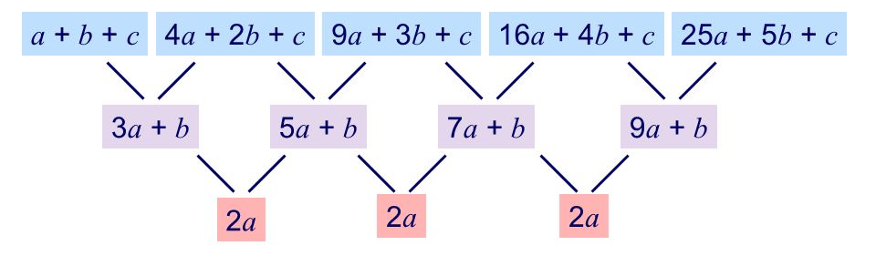
2nd difference
1st difference (2nd-1st term)
2nd term
1st term
To find a, I used the formula 2a=second common difference
2a=2
a=1, which I substituted into the formula 3a+b=1 (the first of the first common differences)
3(1)+b=1
b=-2
I then substituted both values into the formula a+b+c=the first term
(1)+(-2)+c=3
c=4

Therefore, the quadratic sequence is n^2-2n+4 (expressed an^2+bn+c).
We can use the same method to generate any terms in the sequence by substituting positions of numbers in the sequence. For example, the 33rd term would be:
(33)^2-2(33)+4=1027

Other Level 2 and 3 rules I generated included:
Level 2:
Yellow: 1,4,7,10… (is arithmetic as the c.d is the same) = 3n-2
Green: 9,10,13,18,25… (quadratic as the 2nd common difference is the same) = n^2+2n+10
Blue: 7,9,13,19,27… = n^2-n+7

Level 3:
Red: 5,17,29,41… (arithmetic - c.d=12) = 12n-7
Yellow: 10,11,14,19… = n^2-2n+11
Blue: 2,11,20,29… = 9n-7
Green: 6,7,9,12,16 = 0.5n^2-0.5n+6

