For the first table when drawing the graph the line will be steep because as time increases velocity increases as well. The line will be steadily accelerating when looking at the velocity-time graph.
Time (sec) | 0 | 1 | 2 | 3 | 4
Distance travelled (m) | 0 | 9.8 | 39.2 | 88.2 | 156.8

But when looking at the velocity-distance graph the line will look as if it is constantly accelerating. However at the beginning between 0-1 second the distance will increase slowly as both graphs are directly proportional starting from 9.8m at 1 sec. The speed is increasing quickly as the number of seconds increase.

The less reactive you are the longer the ruler has been falling which means it has been travelling for the fastest. The person who caught at 30cm shows that the ruler has been travelling faster than for the other person. When I drew the graph velocity against distance I realised a pattern...

Distance | 0  *0 | 9.8  *1 | 39.2  *2 | 88.2  *3 | 156.8  *4
Velocity | 0 | 9.8 | 19.6 | 29.4 | 39.2

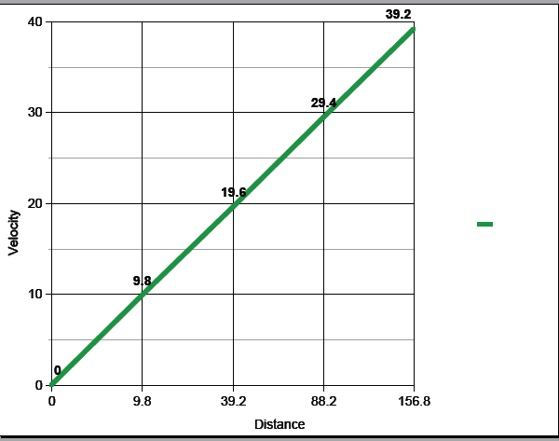

Distance is directly proportional to Velocity. When looking at 2 people’s reactions it shows that the ruler was falling twice as faster than the 1st person. Using the graph if there were 2 people and I assume that the first person who catches the ruler at 44.1m (distance) and the 2nd person at 88.2m. When using my graph it shows that the speed of the 1st person is around 21 or 22m/s when the speed of the 2nd person is 29.5m/s this shows that the speed is not twice as much. This proves that the 2nd person’s speed is not twice as fast as the 1st person. This is the case in the first problem as well. The 1st person is not twice as reactive as the 2nd person.

