King Henry VIII Preparatory School, Coventry
Maths Challenge Club
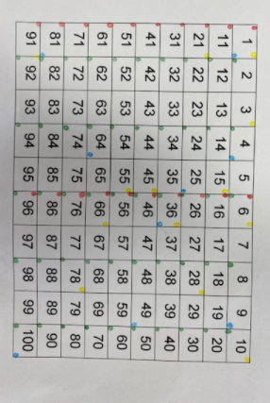
Phoebe and Joshua carefully went through all the numbers from 1-100 looking for patterns. Other people tried a few, then tested their ideas about the rules.
I think that the green light means the number has to be even. I also think that for blue the number must be a square number.
Unaysah
I knew what the green lights were. The green lights were even numbers for example…2,4,6,8,10,etc. Blue numbers were the squared numbers because I first spotted 1 was blue and then 4 was blue for example…9,25,36,49. Reds were adding five every time for example…1,6,11,16,21. Yellow numbers were going one further every time for example…1,3,6,10,15.
Joshua
First I tried out odd numbers but I didn’t see a pattern. Then I tried out even numbers and the green light came on for all of them. Then I tried random numbers which were even and the green light came on for them.
Then I did blue. I looked at the first 10 numbers again and I found that 1, 4 and 9 were all blue. So then I spotted that they were all squared numbers. Then I tried random square numbers and they worked.
Someone else worked out red!
To work out yellow I just went through and I looked at 1, 3 and 6. Then I saw the gap between the numbers was first 2, then 3. I thought the gap would be 4 so I tried out 10 and the yellow light came on. Then I tried a gap of 5 (15) and the light went yellow. Then I did a gap of 6 which got 21 and the light went on. I tried some other numbers up to 30 but these ones were the only ones which went yellow.
The lowest number to light them all up was 36 because it is even, a square number and ends with a 6. It also fits the pattern for yellow.
Daniel

At first, I was unsure about what the lights were doing and meaning until I tried lots of numbers. After a while I could see that all the even numbers had a green light so I wrote it down and checked many times before I was certain that I was correct. Then, I tried to find out the blue lights meaning and when I had put many numbers I was still uncertain. I moved onto the red light and after I saw my first few I knew that it had to end in 6 or 1. The yellow light was left, I tried constantly to find out what it was. Then. I had seen that the difference between all the yellow numbered light’s difference added 1 each time. In the end, I saw that the blue light mean’t that they were square numbers. Also, the smallest number with all lights is 36.
Yishi

