We started with group notation and recording any theories that we thought might be lead to rules for each light.
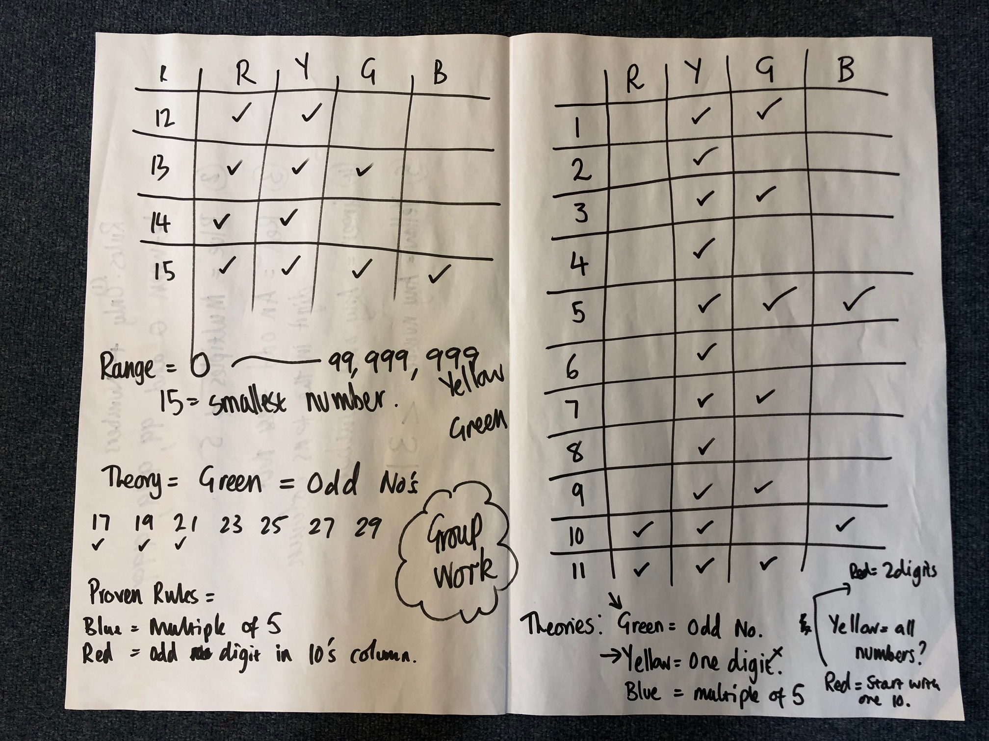
We quickly found that 15 was the smallest number to light all 4 lights was 15.
Children then worked in pairs using the machine to test/prove theories.
The first rule to be proved was that BLUE = multiples of 5.
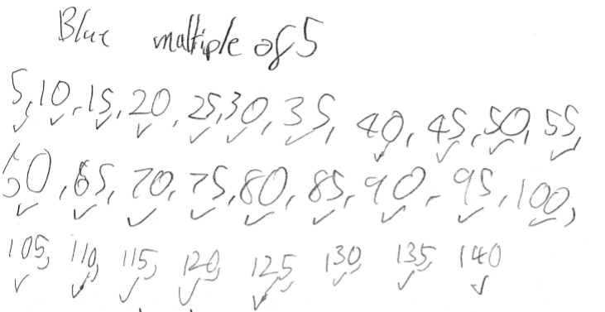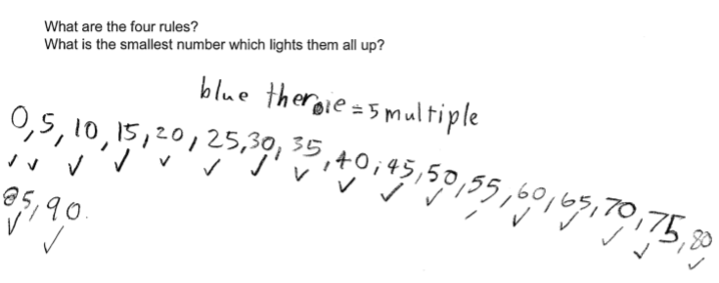
One pair began looking at the theory that red was for a 2 digit number.
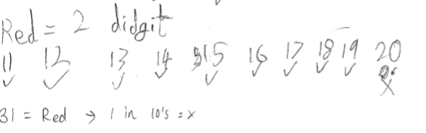
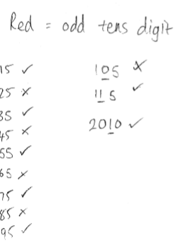
Pupils found that the rule did not work. They could also dismiss the idea that red lit if the number contained only 1 ten.
On finding that 31 lit the red bulb, they proposed that if the number in the 10s column was odd then the red light would be lit. This theory was tested.

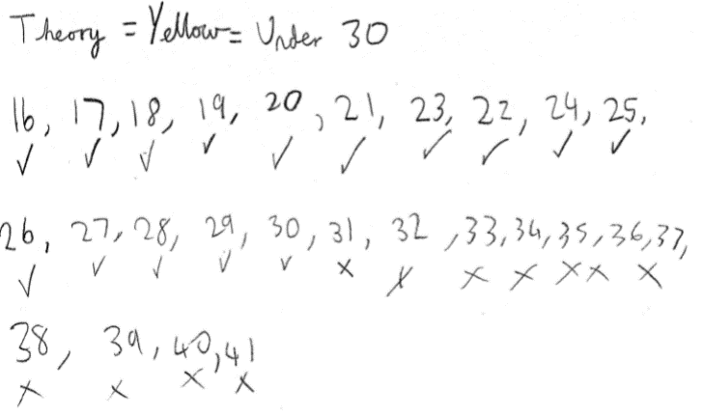
Yellow bulb:
Theory = All numbers - This was quickly proved incorrect by testing for multiples of 5.
The idea that it lit for all numbers under 30 was put forward and tested.
Some discussion took place about if it solution was less than 30 or less than 31!

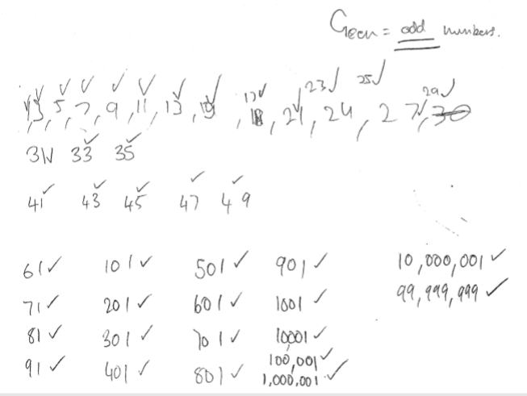
Green Bulb:
All odd numbers light the green bulb:
This theory found the range of the number that could be put in to the machine (0-99,999,999)

Our group suggest that the rules for the light machine are as follows:
