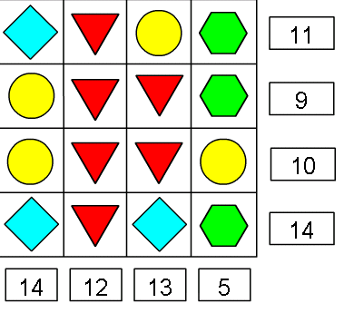
To solve the problem we started by looking at the triangles. They were three because 12 divided by 4 =3.
The circles are two because in the third row we had two threes and two circles 6+4=10.
The diamond and the hexagon then had to be 1 or 5.
The diamonds had to be worth 5 because if you put a 5 for the hexagon in the fourth column it wouldn’t work because it would then the total would be bigger than 5. So then the hexagons had to be worth one.
By Liam Ward and Ollie Davis.

