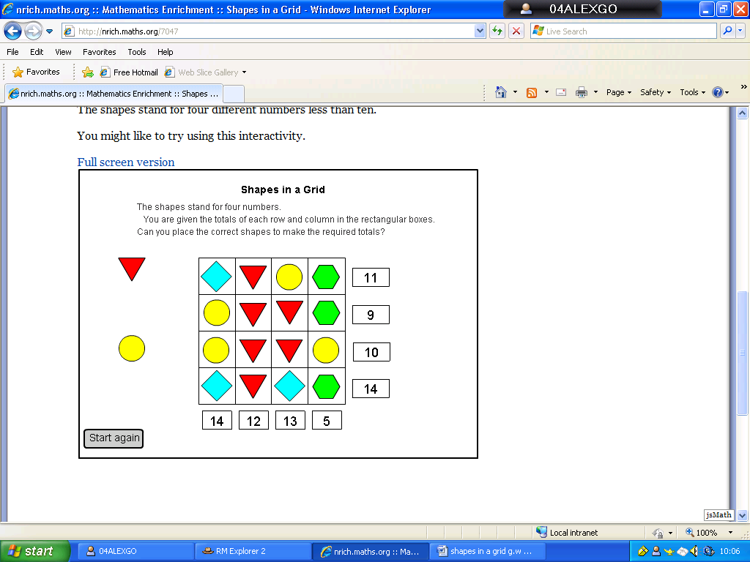

We found the answer when we worked out what the shapes represented. Then we added them together to check they were in the right place.
We started with the triangles as the whole line was full of them so we divided 12 by 4 which make 3.
In the third row circles were 2 because two 3’s are 6 and so the circles must be 2 because if you split 4 in half you get 2.
The diamonds were 5 as 2 3’s are 6 and then add 2 makes 8 so to get 13 you need to add 5.
The hexagon’s 1 as to get 5 when you already have 2 and only 3 spaces must be 1.

Georgia Willis, Megan Worrall and Alex Godwin

