Curve Hunter
Sketches:
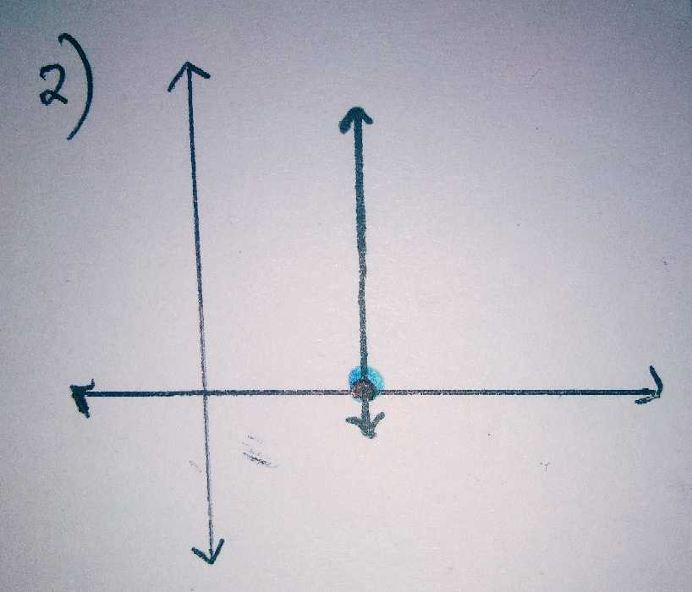
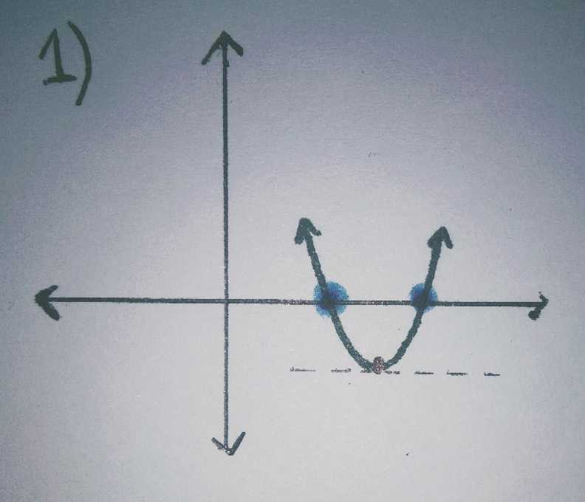
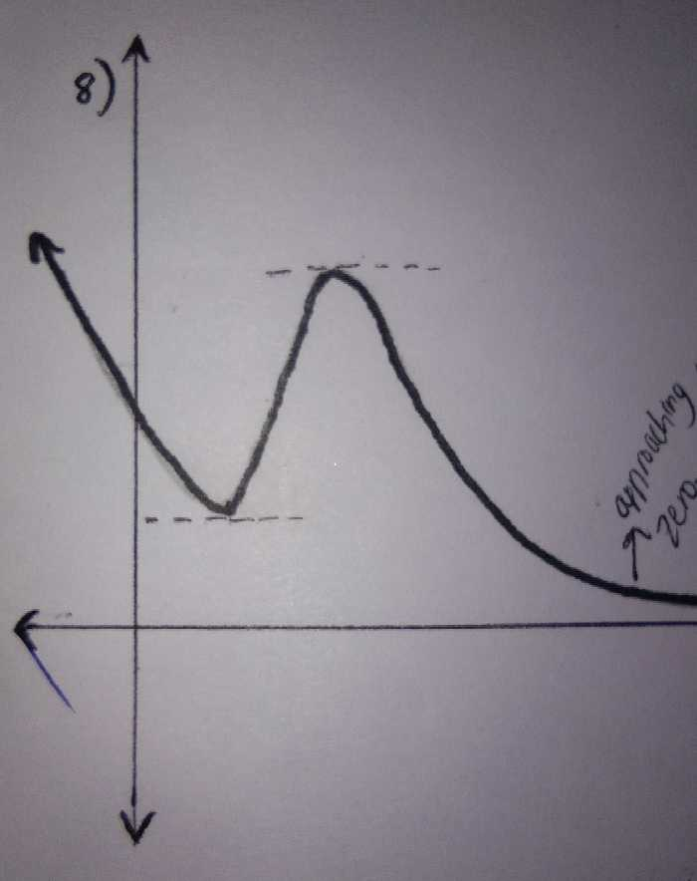
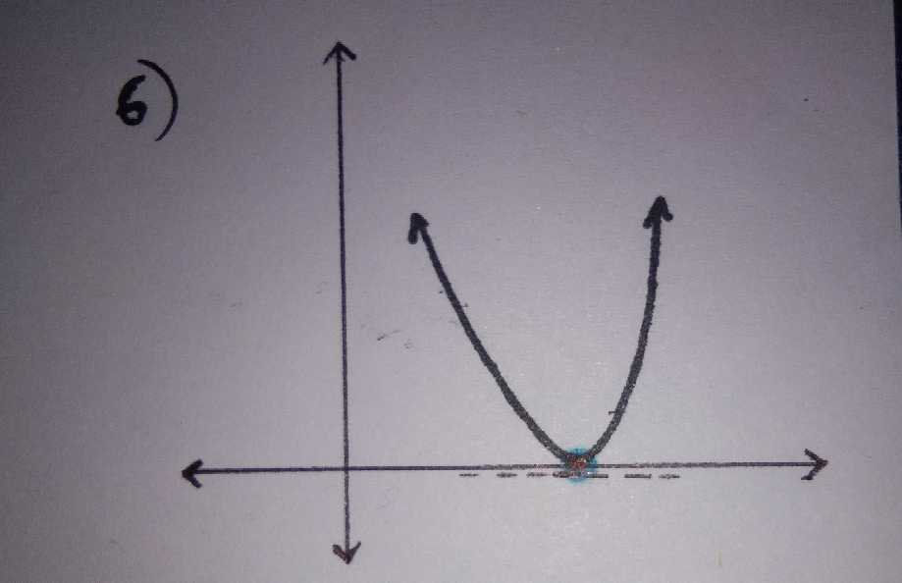
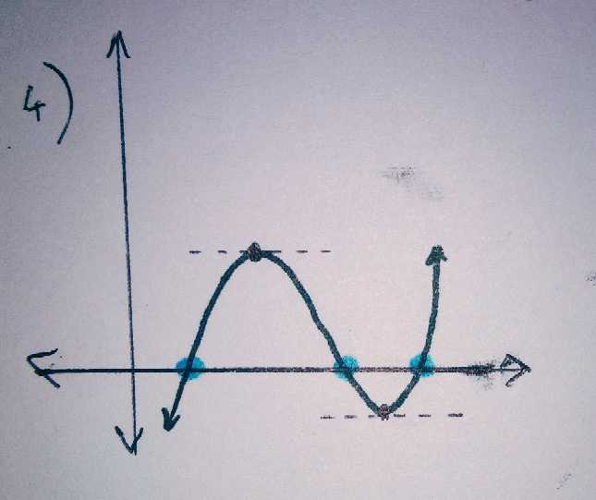
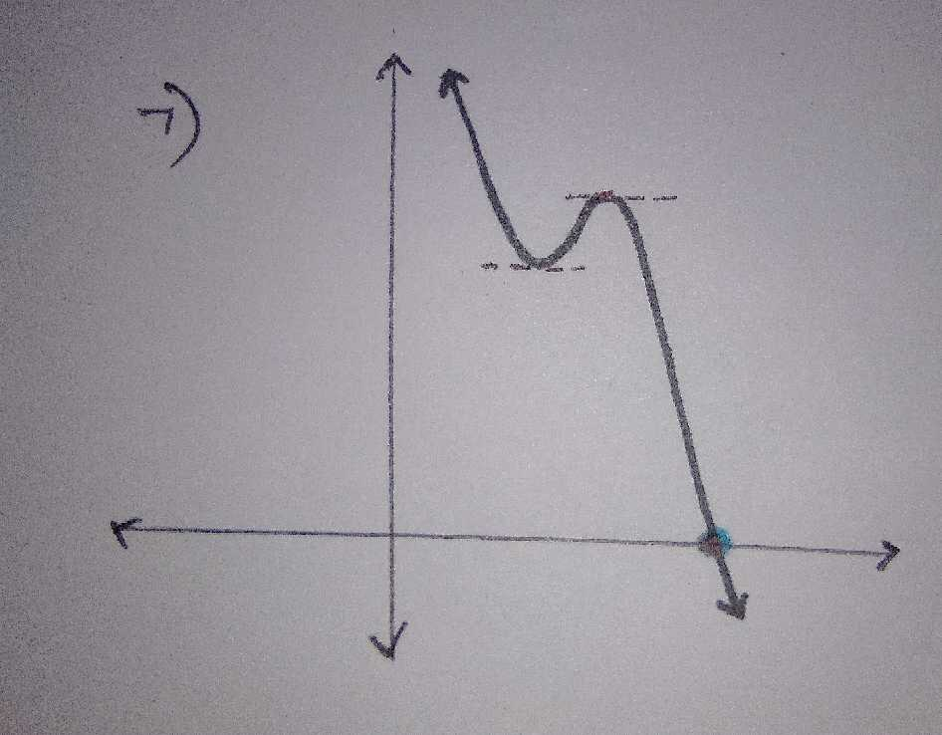
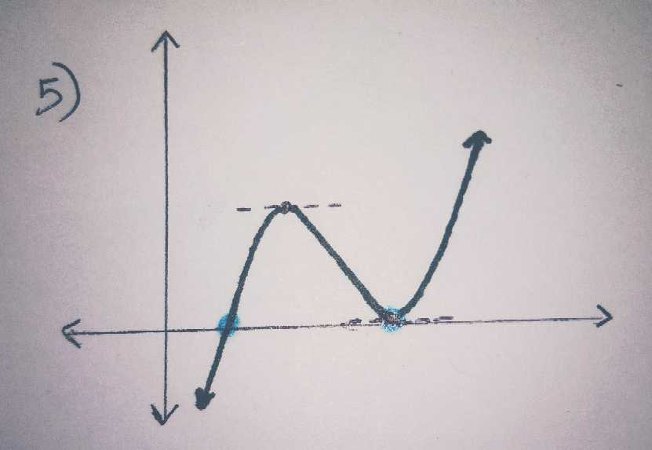
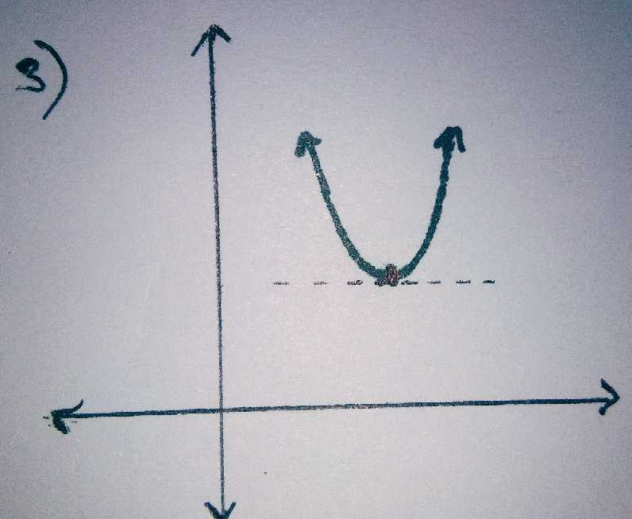

It is not possible to draw a continuous graph with any number of roots and points with zero gradients. For instance, if the number of roots is 2 or more than the number of points with a gradient of zero, then you can’t draw a graph fulfilling all the conditions.
Extension
- $x^{2}-1=y$
- $x=1$
- $x^{2}-x+1=y$
- $x^{3}+6x^{2}+11x+6=y$
- $x^{3}+4x^{2}+5x+2=y$
- $x^{2}+2x+1=y$
- $x^{3}+2x^{2}+10=y$

