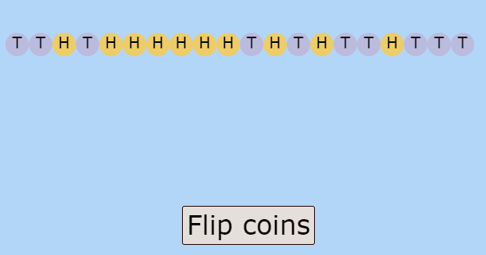

This picture has 10 heads and 10 tails. I would think this is true as there is a 50% chance of getting heads or tails and this diagram clearly shows that the %0% chance has been used.

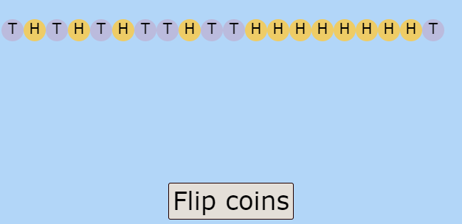

This picture has 12 heads and 8 tails. I would think this is true as even though there is a 50% chance of getting heads or tails and this diagram is close enough as when the two numbers are equal and you add two to make one bigger the difference is 4 as one side is lost two and another has gained two.

When a coin is flipped the chance of getting heads or tails is equal and is 50%. When a coin is flipped 20 times, I would expect the amount of heads and tails to be nearly equal. This means that have 16 tails and 4 heads is exceedingly rare.
When I flipped a coin ten times, I did not only get tails or only get heads. In fact, I got a variety of both. When I flipped the coin, I got 8 heads and 12 tails. They were not any sequences I could spot. In the first time of flipping the coins appeared in the order, heads, heads, tails, tails, tails, heads, tails, heads, heads, tails, tails, tails, heads, tails, tails, heads, tails, heads, tails and finally tails.

