When you flip a coin once there is a 1 in 2 chance of getting just tails. The second time there is a 1 in 4 chance and the third is 1 in 8. We can see here that the probability of getting just tails is 2 to the power of however many times you have flipped the coins.
We now know that there are eight possible outcomes.
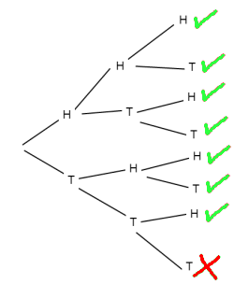This shows that there is a 7 in 8 chance of getting at least one head.

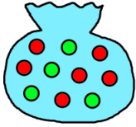If we were to try and take a green ball out of this bag, the probability of you succeeding in one go is 4 in 10. The chance of you getting one in the second go is 4/10 x 4/10 which is 16/100. The chance of it happening again is 64/1000. This is the probability of getting exactly 3 balls.

The probability of getting 2 green balls is 16/100 x 6/10 which is 96/1000. You then have to multiply this by 3 as there are 3 different orders you could get 2 green balls and 1 red ball in. This gives you 288/1000

If you want to get 1 green ball you multiply 4/10 x 6/10 x 6/10 which should give you 144/1000. After this you have to multiply 144/1000 and 3 together so you get 432/1000.

Because the question is what is the probability of getting at least one green ball we have to add 64/1000/, 288/1000, and 432/1000. The end result will be 784/1000 which simplifies to 98/125.
If you were to leave the ball out each time the probability of picking at least one ball is:
120+120+72+120+72+72+24= 600
600/720 = 5/6
This means that there is a 5 in 6 chance of choosing at least one green ball.
G 72/720
R 72/720
G 24/90
R 72/720
G 72/720
R 120/720
G 120/720
R 120/720
R 120/720
R 30/90
R 6/10
G 24/720
G 12/90
G 4/10

