Solutions
First, I started with the question:
Can you work out the rules?
The rules are
Take turns to throw the dice and draw that number of dots in one of the boxes on the grid.
Put all of your dots in one of the boxes. You can’t split them up and you can't have more than six dots in a box.
When a box is full, you could put a tick in the corner like this:
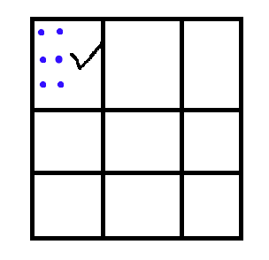
I played it with my brother and it was fun.
Next I made my own game with these rules.
Take turns to throw the dice and draw that number of dots in one of the boxes on the grid.
Put all of your dots in one of the boxes. You can’t split them up and you can't have more than six dots in a box.
When a box is full, you could put a tick in the corner.
Fill all the boxes and the person who fills the most number of rows is the winner.
Here is an example of my version of this game:
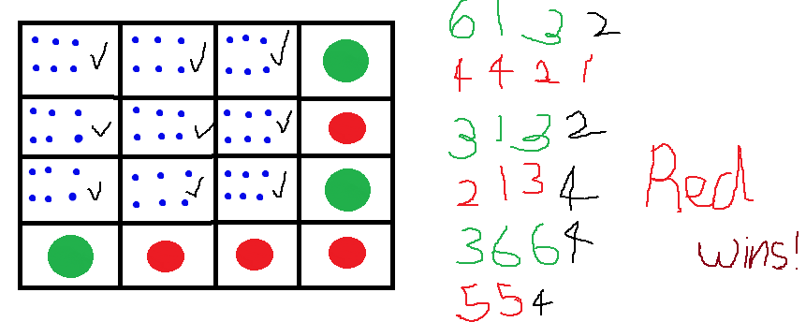

SWAATHI BALASUBRAMANIAN
Year 5, Class 6S
Garden International School
Kuala Lumpur
Malaysia

