http://nrich.maths.org/7344

Which is bigger, n+10, or 2n+3?
How did you decide?
Charlie said:
"I wonder what happens when n=4."
"4+10=14 but 24+3 is only 11."
"So it looks like n+5 is bigger."
Alison said:
"I wonder what happens when n=10."
"10+10=20 but 210+3 is 23."
"So it looks like 2n+3 is bigger."
Can you explain why they have come to different conclusions?
Is there a diagram you could draw that would help?
They have come to different conclusions because they used different values of n.
Value of n | n+10 | 2n+3
1 | 11 | 5
2 | 12 | 7
3 | 13 | 9
4 | 14 | 11
5 | 15 | 13
6 | 16 | 15
7 | 17 | 17
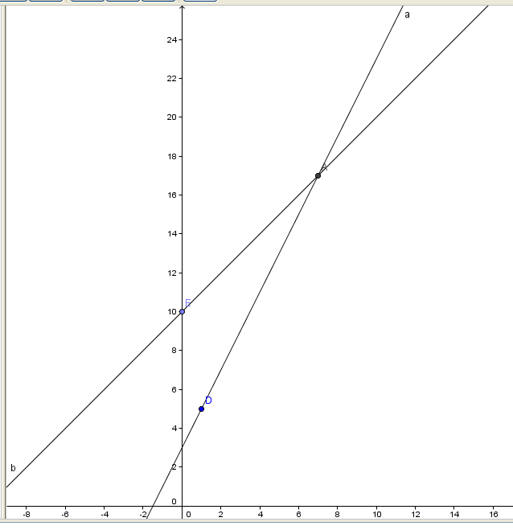

…And 2n+3 is greater after n=7 that because n+10 is only increasing by 1 but 2n+3 is increasing by two. You can also see the graph to see that 2n+3 gets bigger after n=7.(Graph from Geogebra)
For the following pairs of expressions, can you work out when each expression is bigger?
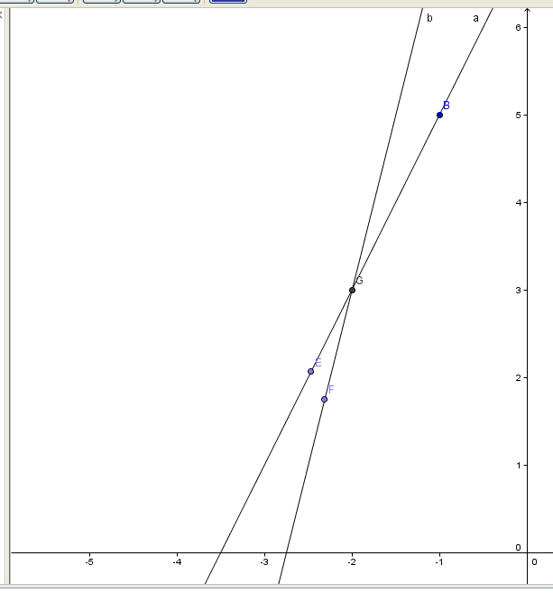
2n+7 and 4n+11: 4n+11 becomes bigger after n= -2 because at n= -3, the equations are 1 and -1 precisely. At n= -2, they are both 3 and at n= -1 the values are 5 and 7. You can also see the graph below.

2(3n+4) and 3(2n+4): 3(2n+4) will always be bigger because when you expand the brackets they become 6n+8 and 6n+12, so 3(2n+4) will always be bigger.

2(3n+3) and 3(2n+2): They are both the same value as when you expand the brackets, they are both 6n+6. So they have the same value no matter what n equals

Here are some challenges to try:

Find two expressions so that one is bigger whenever n5 and the other is bigger whenever n5. Ans: –n+5, n-5

Find three expressions so that the first is biggest whenever n0, the second is biggest whenever n is between 0 and 4, and the third is biggest whenever n4. Ans: -6n, -n+4, n-4

Find three expressions so that the first is biggest whenever n3, the second is biggest when n3, and the third is never the biggest. Ans: -n+3, n-3, n-4

Find three expressions so that one of them is the biggest regardless of the value of n.
Ans: n, n+1, n+2

