Which Is Bigger

The solution to “Which is bigger n+10 or 2n+3?” can visually be presented on a graph. The green line is n+10 and red line is 2n+3. (n being on the x axis on the graph)

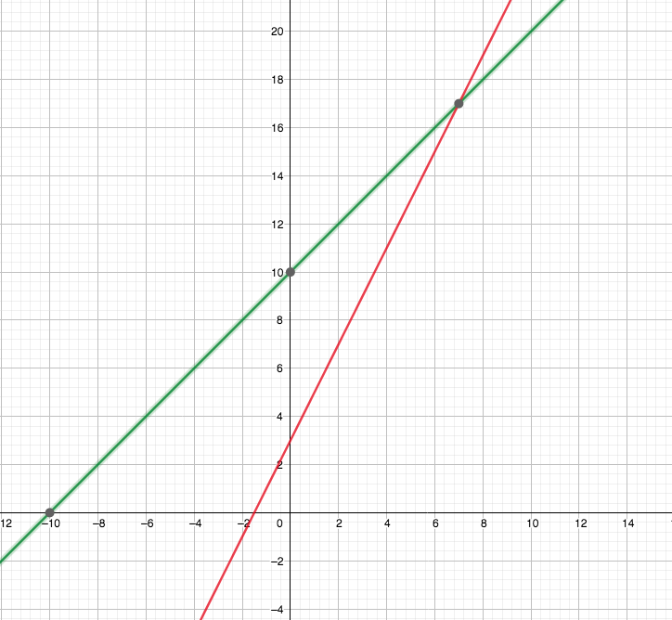

From the graph we can see that the intersection of the lines is (7,17).
This could also be solved as an equation:
$$n+10=2n+3$$
$$n=7$$
Thus, when n>7 then n+10>2n+3 and when n<7 then n+10<2n+3.

The next question is which expression 2n+7 or 4n+11 is bigger. Again this can be solved algebraically or graphically. The red line is y=4x+11 and the green line is y=2x+7
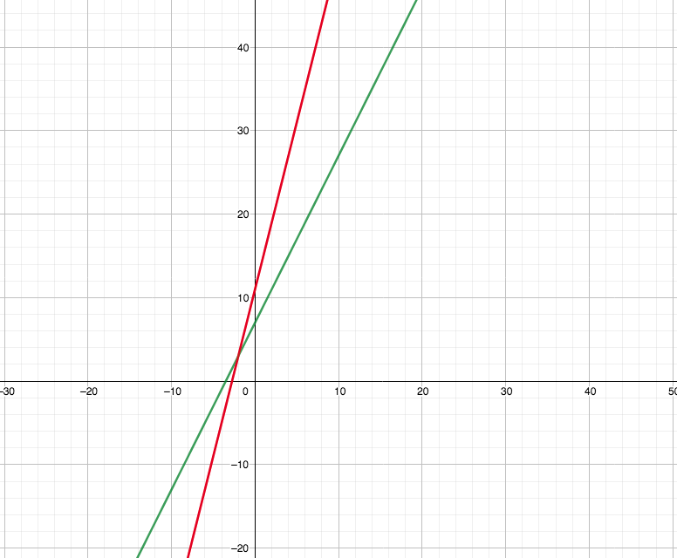
On a graph we can see that the point of intersection is (-2, 3)
So when n>-2 then 4n+11>2n+7 and when n<-2 then 4n+11<2n+7
For which of the expressions 2(3n+4) or 3(2n+4) is bigger again a graph can be constructed. The green line is 2(3n+4) and the red line is 3(2n+4).
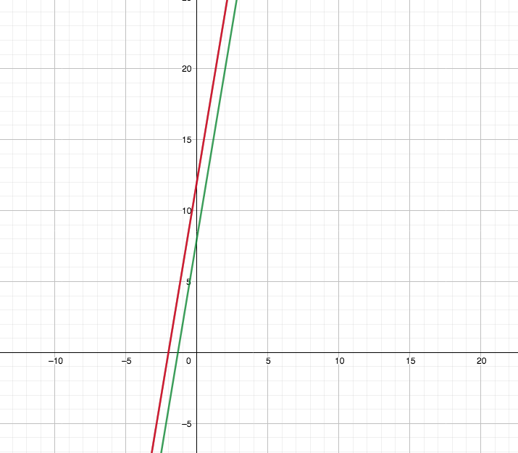
As can be seen on the graph, they are parallel lines because they have the same gradient but different constants. As a result of them being parallel lines, one of them must always be bigger. In this case we can see it is the red line, 3(2n+4).

Further, if the expressions are rearranged they become 6n+8 and 6n+12. This makes it more obvious that the second expression will always be bigger.

To find two expressions where one is bigger when n>5 and the other is bigger when n<5, the point of intersection of the expressions must be x=5.
$$x=5$$
$$3x=2x+5$$
$$18x=12x+30$$
I added 2x then multiplied both expressions by 6 to reach two expressions with an intersection point of 5. So when n>5 then 18n>12n+30 and when n<5 then 18n<12n+30.

To find three expressions where the first one is the biggest when n<0, the second one is the biggest when 0<n<4 and the third is the biggest when n>4 the intersections of the first and second line need to be x=0 (Point I) and the intersection of the second and third line needs to be x=4 (Point J).
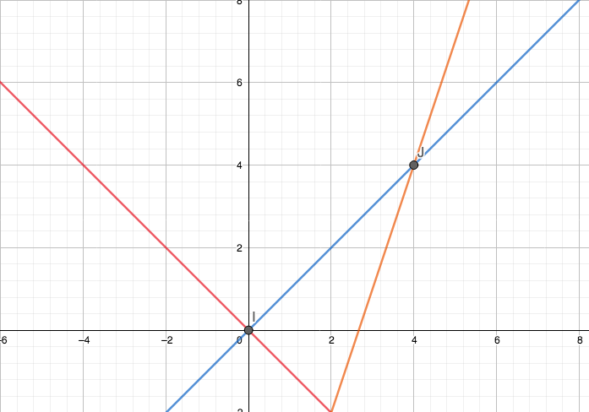

With the graph it is visually demonstrated which value is the largest at any value of n.
The equation of the first expression (red) is -n
The second expression (blue) is n
The third expression (orange) is 3n-8

To find three expressions for which the value is largest regardless the value of n. The expressions will have the same gradient but different constants. Thus they are parallel and don’t have a point of intersection. Regardless of the value of n the first expression will always be larger than the second and third.

First expression is 2n+10
Second expression is 2n+5
Third expression is 2n+3

