Which is the most naturally athletic country?
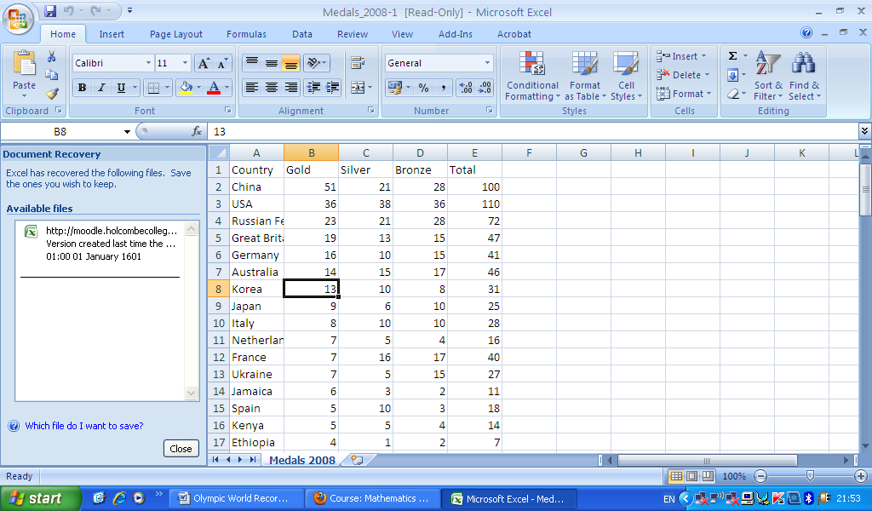
As you can see, in the top five comes China, USA, the Russian Federation and Great Britain.
China
China has the world’s largest population, with it being 1,331,460,000 (2009, a year after the Olympic). China itself, as in the Government, is quite rich and can afford extensive training. China was the host and had 639 athletes at the Olympics.
USA
The population of the USA is 307,006,550 (2009). It is a very rich country and can afford the best for her athletes. The United States had 596 athletes.
Russian Federation
The population of the Russian Federation is 141,850,000. Russia sits on natural resources like oil, so its very rich. It had 467 athletes
Great Britain
The population of Great Britain is around 59 million people. We may be having financial problems, but we are still a relatively rich country. She had 312 athletes.
Germany
The population of Germany is 81,879,976. It is a very rich country, being the richest in Europe. It had 463 athletes at the Olympics
Australia
The population of Australia is 21,874,900. It is a wealthy country. It had 433 athletes,
Korea
Population of Korea is 72,653,070. Korea is quite rich but not as rich as the other countries. Korea had 330 athletes.
The most naturally athletic would be Australia, with Britain in second. I think the top three’s wealth and population stopped them for being the most athletic. Germany and Korea both have big population compared to the Great Britain and Australia. Compared to the other countries Australia had the lowest population but still managed to field many athletes because they are naturally athletic.

