The Time Is… May 2011

12 Hour Clock Times
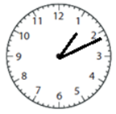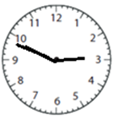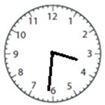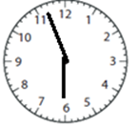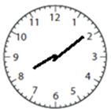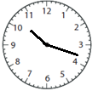
(1:11) (2:49) (3:31) (6:56) (8:13) (10:18)

12 Hour Digital Times

2:56 5:02 7:49 9:37 11:04 12:17

24 Hour Clock Times

1st set

0:26 14:13 16:39 18:44 20:41 22:44

2nd set

00:17 13:13 15:58 18:42 20:59 22:29

