Factors And Multiples Graphs
By Michael Slack
Using the rules given, I attempted to see what the highest amount of numbers I could include in a factor/multiple graph was. I also set myself the condition of only drawing fully connected graphs, i.e. islands of factor/multiples are not allowed.
(BTW, I apologise for the poorly scanned-in diagrams in advance!)

Attempt 1
Rather than just trying random numbers, I attempted a logical approach. After some doodling, I quickly came to the conclusion that not every number from 1 to 100 could be included. If my graph was going to be fully connected, then I would definitely need the number 1 to feature, since all of the numbers on my graph will be multiples of 1. This seemed the only way to connect large prime numbers. So I started by drawing a 1 in the centre of my page.
I then proceeded to write all the primes around it, and then multiples of these primes, connected them all to each other where necessary.
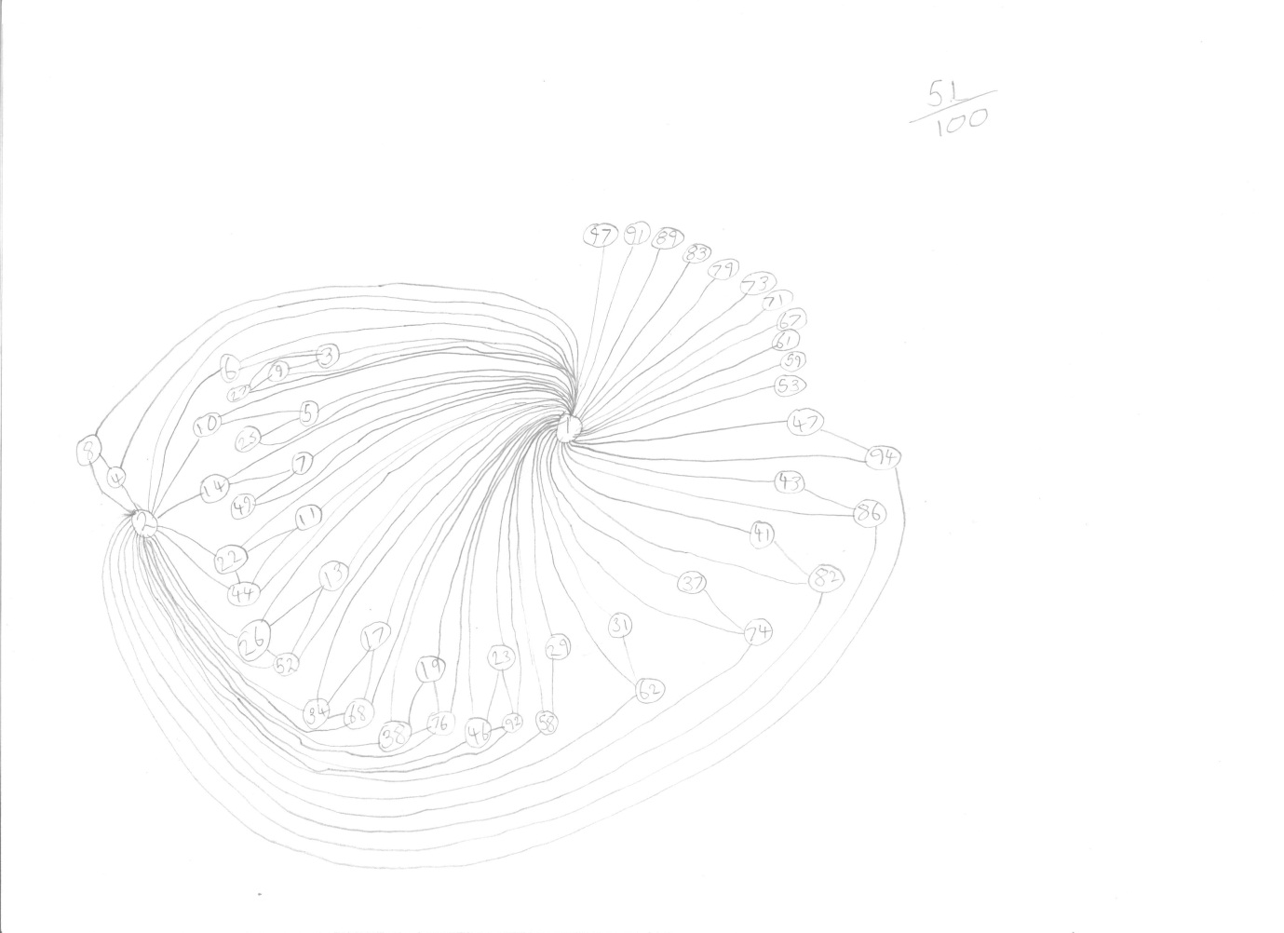
(This diagram has two mistakes: there’s a rogue 91 near the top, and the total only comes to 50, not 51)
50% seemed like quite an achievement, but I thought I could do better.

Attempt 2
In my previous attempt, the number 1 seemed a bit busy, so this time I followed a similar approach but started with 2 instead of 1. This made things easier since it freed up numbers by not requiring them to connect to 1. I ended up with this.
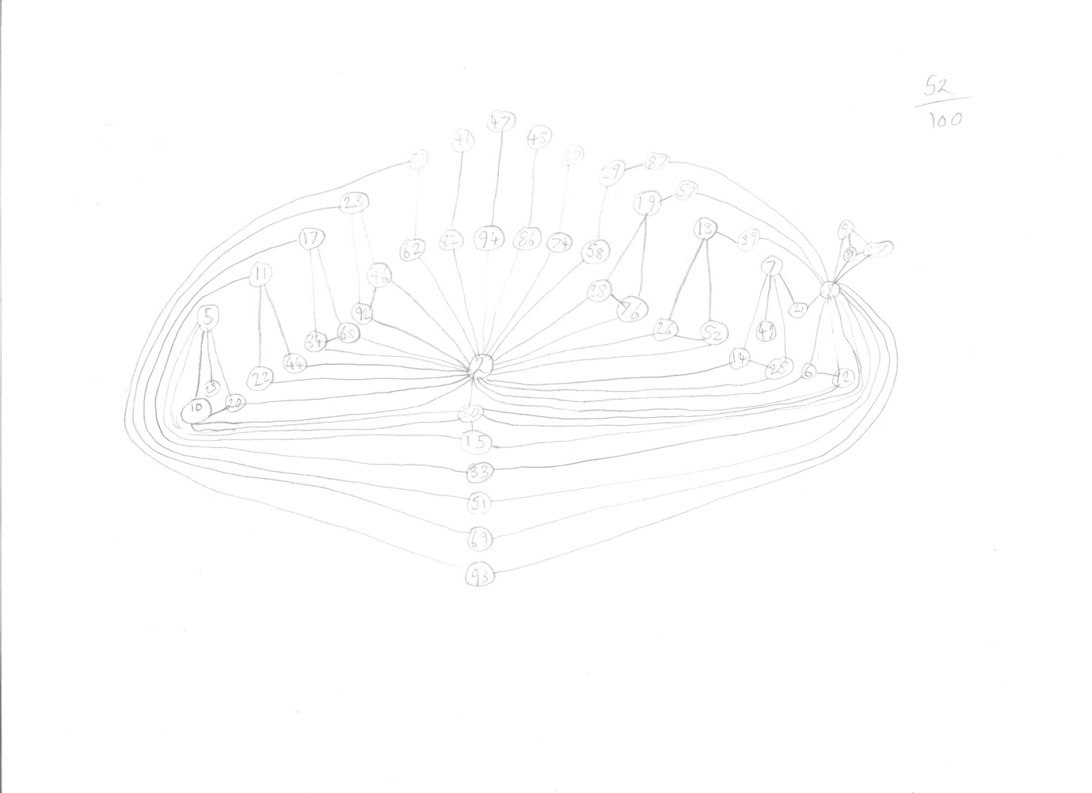
(This diagram is incomplete: the number 93 could feature, probably along with one or two others. However, in the middle of drawing this diagram, I had an idea for a better approach.)
This method produced better results, covering at least 52 or 53 numbers, but it still wasn’t brilliant. It blocked off the inclusion of many numbers, specifically the primes greater than 50, since they shared no factors or multiples with any other numbers (without the presence of 1)

Attempt 3
This was my final attempt, and also my best. First, I kept in mind that my graph can eventually be fully connected using the number 1.But this time, I didn’t start with 1, I started with 100. This came from the realisation that I could draw the numbers 100, 99, 98, …, 51 without having to draw any connections, and then add 1 for a fully connected graph. In fact, this could be generalised; for a list of integers from 1 to $n$, a fully connected graph can be drawn featuring at least $1/2n$members of this list.
With these first 49 digits down, I then proceeded down the list of numbers, adding 50, then 49, then 48, and so on. I kept this up till I got all the way down to 15, which I found to be impossible. The only way that it could connect to its multiples was by blocking one of them off from any further connections. This was a problem, because I still hadn’t added the number 1 yet, which was needed to connect my graph come the end. So 15 was the first number to be excluded from my diagram.
The numbers 14 and 13 fitted in easily after this, but from then on, the remaining numbers had the same problems as the number 15. I therefore ended up with this diagram.
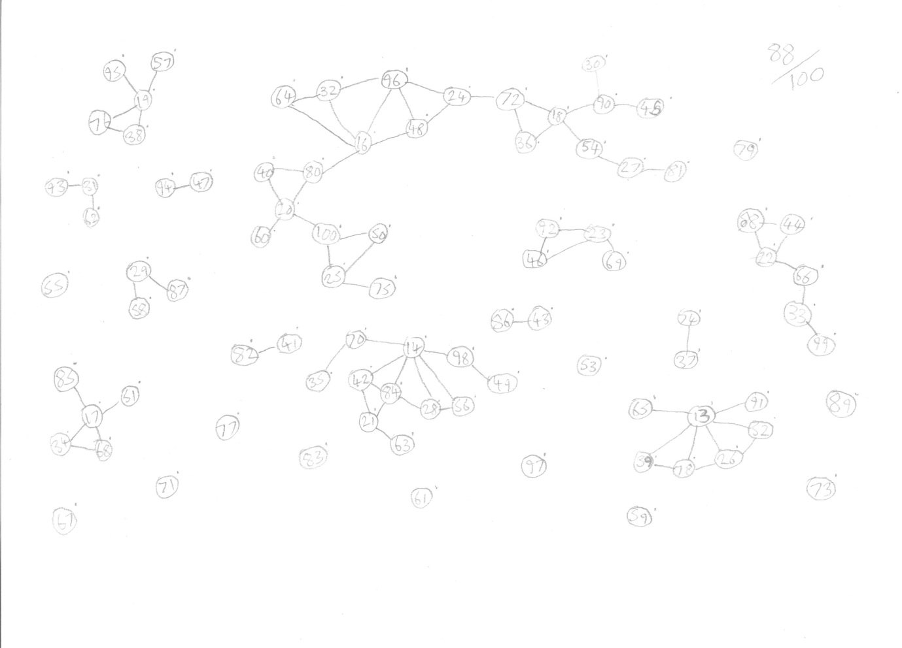
(No mistakes this time… I think!)
This diagram is not yet complete: all it requires is the addition of the number 1, which I haven’t done yet because I wanted the diagram to remain clear. However, I do know it to be possible, because all the numbers on the page are on the exterior of their sub-diagram islands. This allows direct access for the connections to 1.
(Having now added 1 to my diagram and drawn the connections, I can report that my page has just become an unintelligible mess od swirling lines!)
This method created a diagram of 88 numbers (if you include the 1 not featured on my diagram above). I would bet that this number can’t be topped for the numbers 1 to 100, but I can’t offer any proof for this conjecture.

