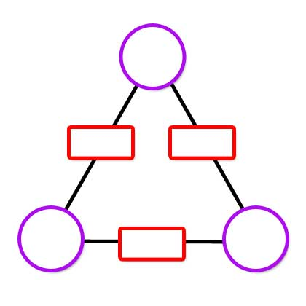
Z
Y
X
C
A
B
TO NRICH from Rajeev Kumar
If I am given the value of the vertices then then I can work out what value belong in the edges by doing the equations
AB = X
BC=Y
AC=Z
So for example if B=8 and c=9 and A=77 then Y=72, Z=693 and X=616.
You can work out the values at the vertices irrespective of the value given for the edges. The strategies are:-
Square root of XY/Z = B
Square root of XZ/Y= A
Square root of YZ/X = C
There is a relationship between the product of the values at the vertices and the product of the values on the edges. The product of the values at the vertices is the square root of the product of the values on the edges.
What happens to the numbers at the vertices if you double, treble etc one or more numbers on the edges? If you double one of the numbers on the edges then two of the numbers on the vertices will double.
Here is an example where I will treble the 4 in the bottom left vertice and the two edges next to it will treble
7
12
11
11
84
132
77
7
28
4
77
44

You can create a multiplication arithmagon with fractions at some or all of the vertices and whole number on the edges.
12
16
4/3
27
3
9/4

