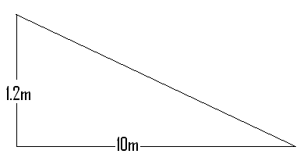
$$a^{2}+b^{2}=c^{2}$$

(1.2x1.2) + (10x10) = 101.44
C = 10.07174265
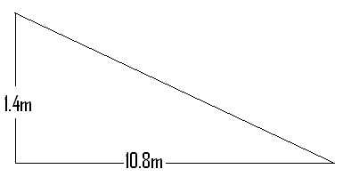

(1.4x1.4) + (10.8x10.8) = 118.6
C = 10.89036271

