Our Solution.
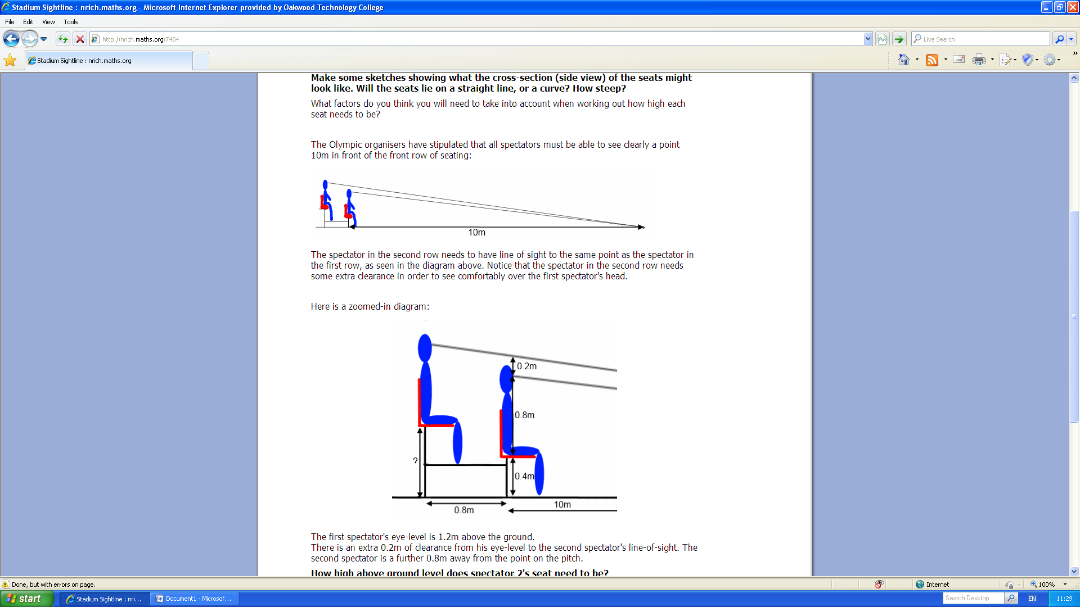
Firstly, we worked out the hypotenuse of the smaller triangle (10 squared + 1.4 squared = 101.96. Square root = 10.09752445).
We then worked out the smaller triangles angle (Using the Sin rule for angles). Sin 90/ 10.09752445 = Sin x/1.2.
X = 10.71495115
Then we worked out the Green angle. 180 – (x +90) = 79.28504885
We then worked out the purple angle, because we know that they are the same.
We then worked out the blue side. S/ Sin 10.71495115 = 10/Sin 79.28504885
S = 1.892222383
S -0.8 = 1.092222383 = ?
Therefore you will increase each chair 0.6922223825.
The height of 40 rows = 36.4888953m

