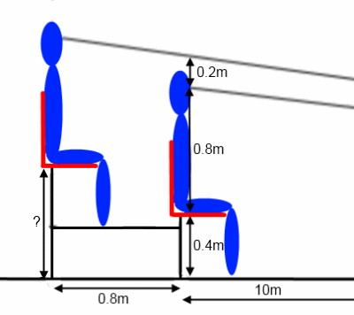 0.4 +0.2=0.6 m ?=0.6m
X+0.2=2x
3rd spectator= 0.8m
40th= 8.2m

