Olympics challenge

Can you deduce which event each graph represents?
Here are some questions to consider, which may help you to make sense of the graphs:
Can you determine what the units might be on the vertical axis for each graph?
Why do some graphs show a decreasing trend and some an increasing trend?
Are there any unusual features on any of the graphs? Can you think of a plausible explanation for them?

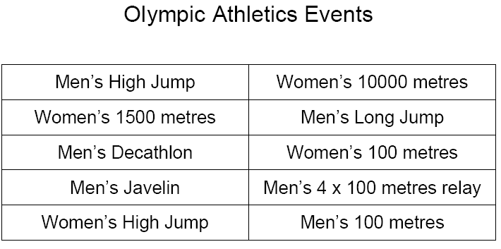

Graph 1
Information about the event given by the graph:
The line has a negative correlation.
The records start from about 1889.
The average score is around 10.
Comparing graphs from the records and the internet show that it is the Men’s 100m

Graph 2
Information about the event given by the graph:
The graph has a positive correlation.
The records start from about 1889
The average score is around 7.5
Comparing graphs between the records and internet show the event is the Men’s longjump.

Graph 3
Information about the event given by the graph:
The graph has a negative correlation.
The records start from around 1970 and end around 1989
The average score is between 03:36.0 and 04:19.2
The measurement of score appears to be set out in the format of space of time
The shortages of result show that the event was only available for a short space of time.
According to the evidence the main plausible answer would be the women’s 1500m

Graph 4
Information about the event given by the graph:
The graph has a positive correlation.
The records start from around1889
The average score is 2.05
The world record is the same as the score on graph for the men’s high jump. This gives aspirate evidence to conclude the event is the men’s high jump.

Graph 5
Information about the event given by the graph:
The graph has a positive correlation.
The records start from around1910
The average score is 75
According to the measurement of score it is possible the graph resembles the men’s javelin

Graph 6
Information about the event given by the graph:
The graph has a positive correlation.
The records start from around 1930
The average score is 1.85
The method of scoring and the record both lead to show the graph is the women’s high jump

Graph 7
Information about the event given by the graph:
The records start from around 1910
The average score is 8400
The method of scoring and the record both lead to show the graph is the decathlon

Graph 8
The method of scoring and the record both lead to show the graph is the women’s 10000m

Graph 9
The method of scoring and the record both lead to show the graph is the mens 4x100m

Graph 10
The method of scoring and the record both lead to show the graph is the men’s 100m

