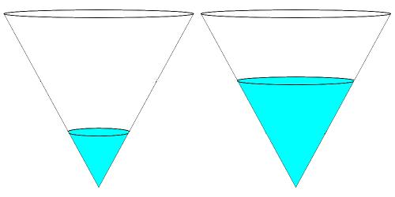
4
2
2
4
2
4
- In the second picture, the height of the water level has doubled. How has the volume of water changed?
Although the height has doubled the volume of the cone has more than doubled. Since the volume is height x width x length. Both the length and the width have increased with the height. Therefore the volume will be more than half. For example if the height was 2cm, the width and length might also be 2cm; therefore the volume would be 8cm cubed. If the height was doubled the height would be 4 cm, the width, and length might also be 4 cm; therefore the volume would be 64 cubed.
- What if the height had trebled?
The same rule would apply. The volume would have more than tripled. For example if the height was 2cm, the width and length might also be 2cm; therefore the volume would be 8cm cubed. If the height was tripled the height would be 6 cm, the width, and length might also be 6 cm; therefore the volume would be 216 cubed.
- What if the height had increased by a factor of n?
The same rule would apply. You cube n.
- How would I need to increase the height in order to double the volume?
2 cubed = 8 2.5198421 cubed =16
- How would I need to increase the height in order to treble the volume?
2 cubed= 8 2.8844991405 cubed = 24

- What would a graph of volume (y) against height (x) look like?

- What would a graph of height (y) against volume (x) look like?

