What’s That Graph?
Link: https://nrich.maths.org/7502

Task 1, Task 2 , Extension
- A cup of tea is made and the temperature measured in degrees Celsius every second. What would the temperature - time graph look like?
y=A/(e^x)+B
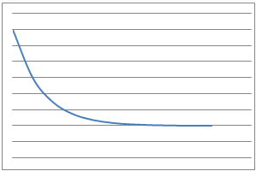
- The height of the valve on a bicycle tyre above the ground is measured after each centimetre that the bicycle travels forwards. What would the height - distance graph look like?
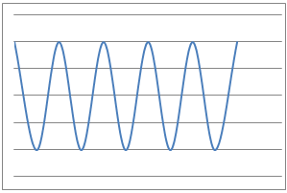 A = 12
- I throw a tennis ball straight up into the air and catch it. The height of the ball from the ground is measured over the time of the journey using freeze-frame photography. What would the height - time graph look like? y=A(x^2)
A has to be a negative number.
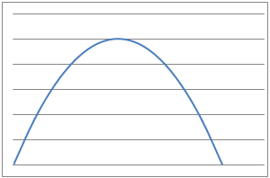

- I measure several objects using inches and then using metres, plot them on a scatter graph, and join the points. What would the metres - inches graph look like?
y=Ax
A definitely has to be more than 0.
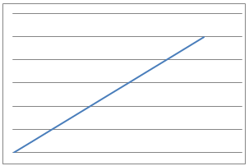
- I jump out of a plane and the distance fallen from the plane is measured every 0.1 second until I open my parachute. What would the distance fallen - time graph look like whilst in freefall?
y=A(x^2)+Bx+C
A must be more than 0. If A was negative, it would instead be an upside-down parabola. I think B and C may be 0.
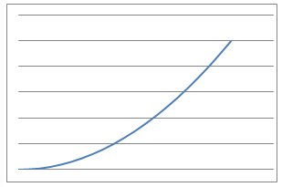
- I drive at 70 miles an hour along the motorway and note the reading on my odometer (mile counter) every 5 minutes. What would the odometer reading - time graph look like?
y=Ax+B
A is an incredibly small positive fraction and B is 1 because the line has a y intercept at (0,1)
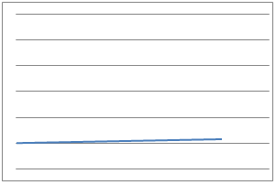

- I blow up a roughly spherical balloon using a balloon pump. After each pump I measure the radius of the balloon in centimetres. What would the radius - number of pumps graph look like? y=A(√3 x )
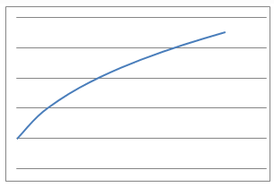
- I suck water through a straw out of a large beaker at a constant rate and measure the volume of liquid remaining at various times. What would the volume-time graph look like?
y=Ax+B
A is negative and B is 5 because the line crosses the y axis at (0,5).
