We have found a possible solution to the scoring system
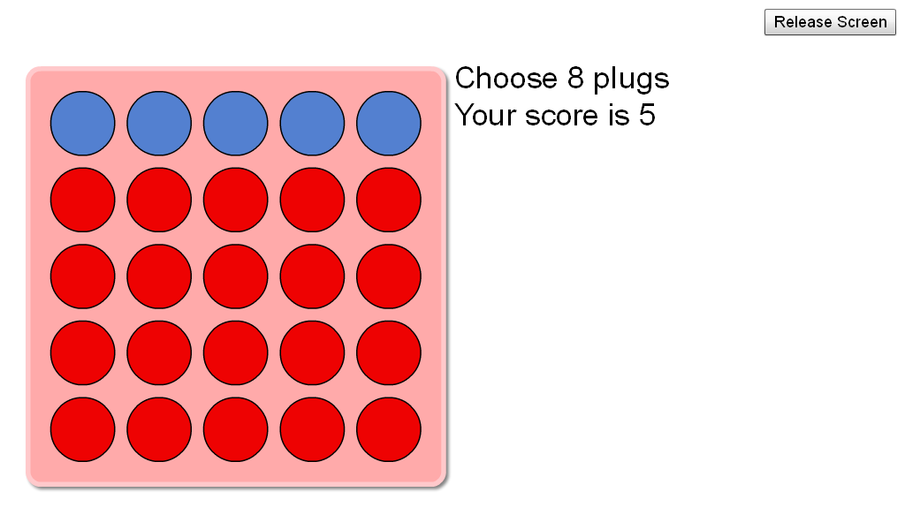
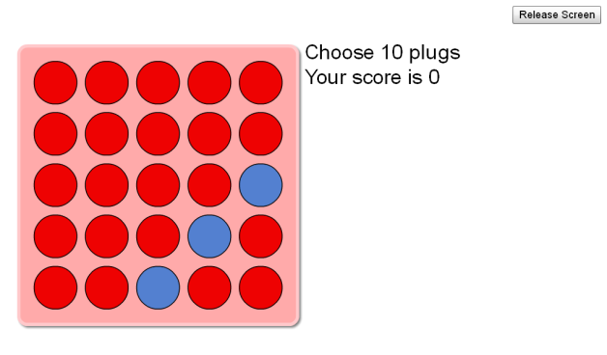
Vertically, horizontally or diagonally, if you have three or more in a row you score points. So for instance if you have three in a row you score three points, add one more and you score four points add another and you get five. Once you make another row/ column/ diagonal of three or more you add the amount of points. Apart from the diaganol in the bottom right corner of three plugs.
