Maths – Score sheet
For every block of 3 per row, column or diagonal you get 3 points. This is the pattern is continous. For example 4 blocks per row, column or diagonal is 4 points and 5 blocks per row, column or diagonal is 5 points.
However, one exception to this rule which is in the bottom right corner when trying to make a full diagonal of 3. This, according to theory, should score you 3 points but it doesn’t give you any. We think that this is due to a fault with the game in itself.
The Fault
Example of a full score
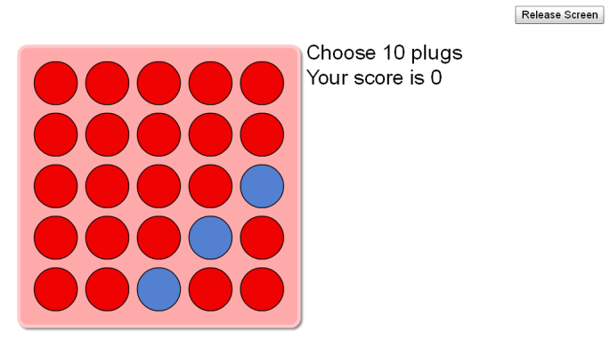
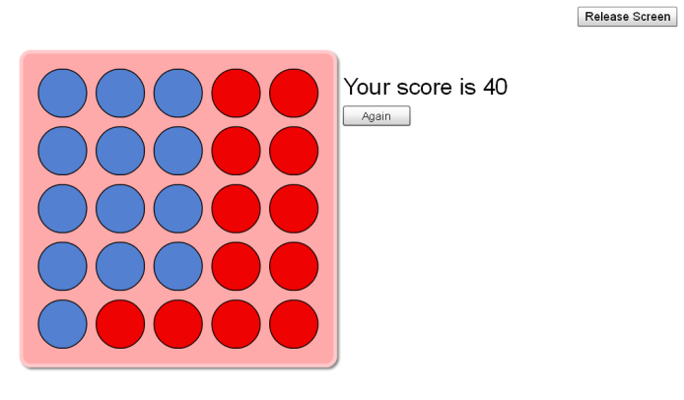

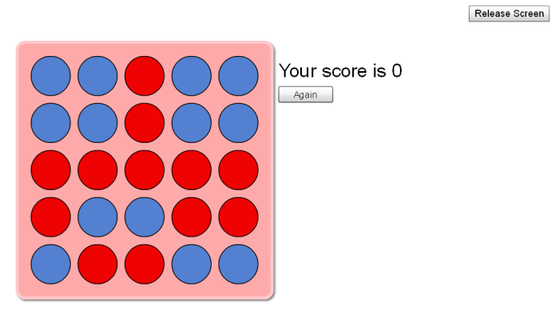
Example of no score

