Polyplug Instructions
All of the diagonals count (as shown in the picture).
3 in a row/column/diagonal = 3 points
4 in a row/column/diagonal = 4 points
5 in a row/column/diagonal = 5 points
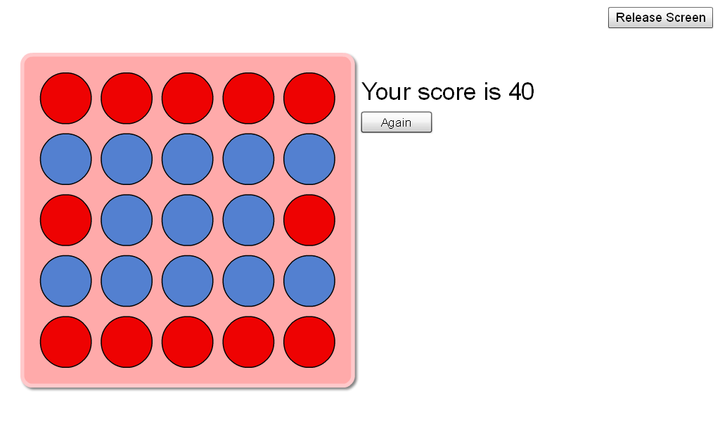
In picture, there are 10x 3 dots, & 2x 5 dots
(10x3=30) + (2x5=10) =40

