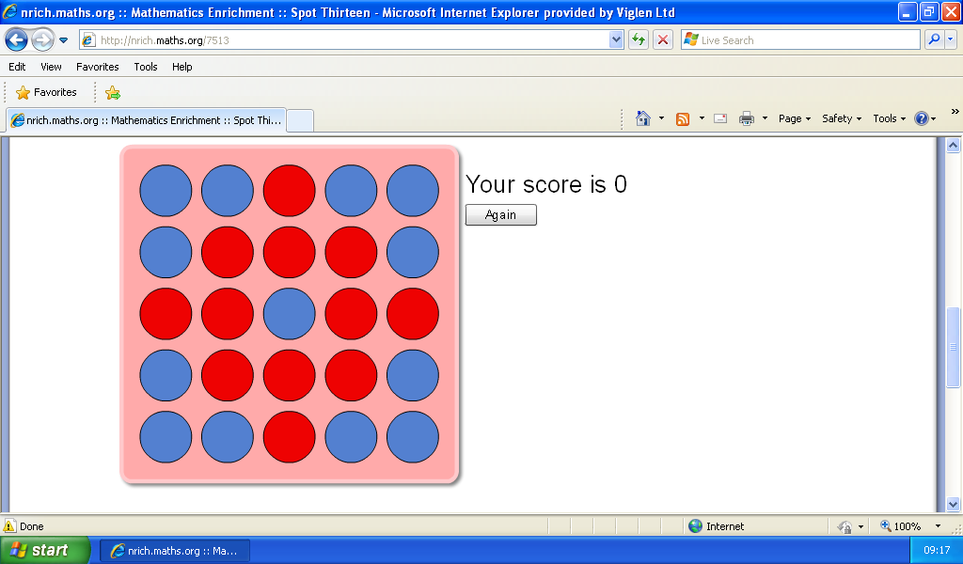
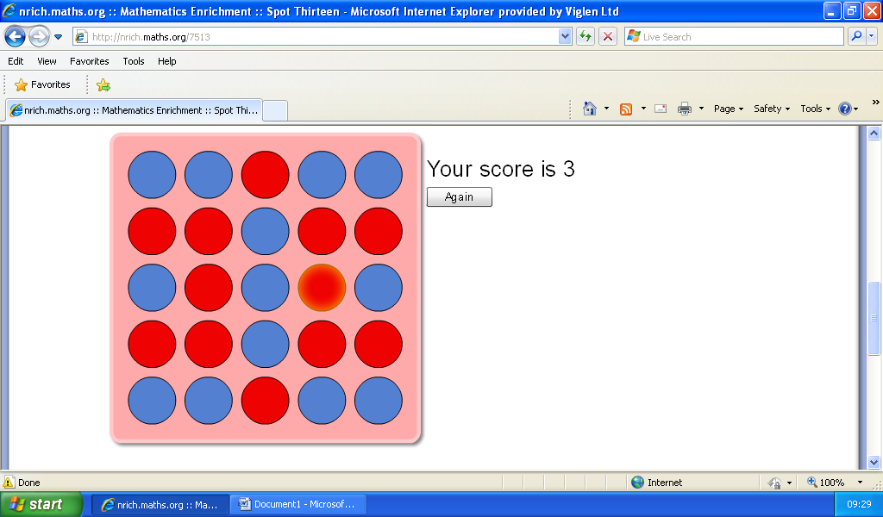This is a score of 0.
You can get a score of 0 by puting the plugs in to the corners and then puting one in the middle or some were else but they cant touch the one of the ones what a gatherd togather.

