This is the graph we made altogether to show how many boys and girls are in our class.

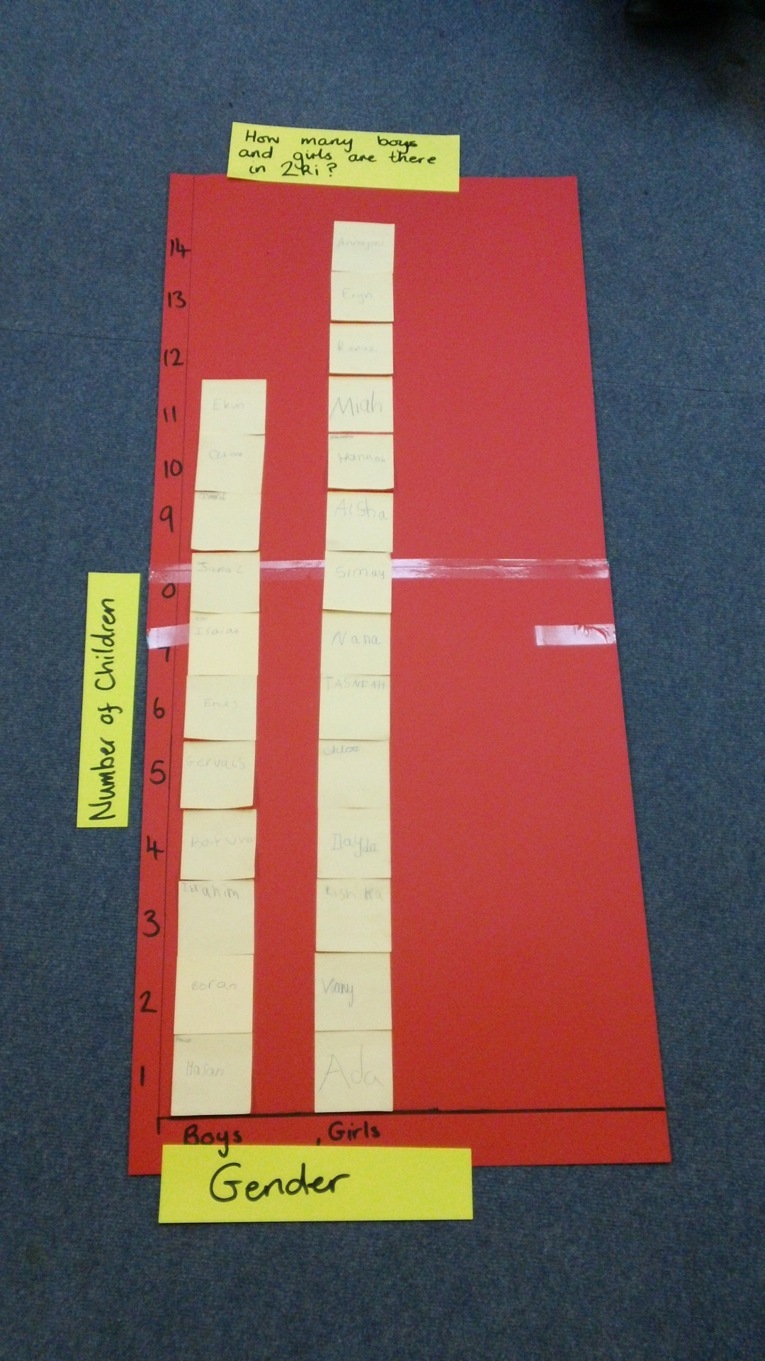
Rishika
We made a graph titled “What subject do you like best?” Then we labelled our axes ‘subjects’ and ‘number of children’. Our subjects were maths, science, English, art and topic. We found out that most people voted for maths (18 people). The least favourite was topic. The same number of people liked English and science. Then we used our graph to ask questions about the data.

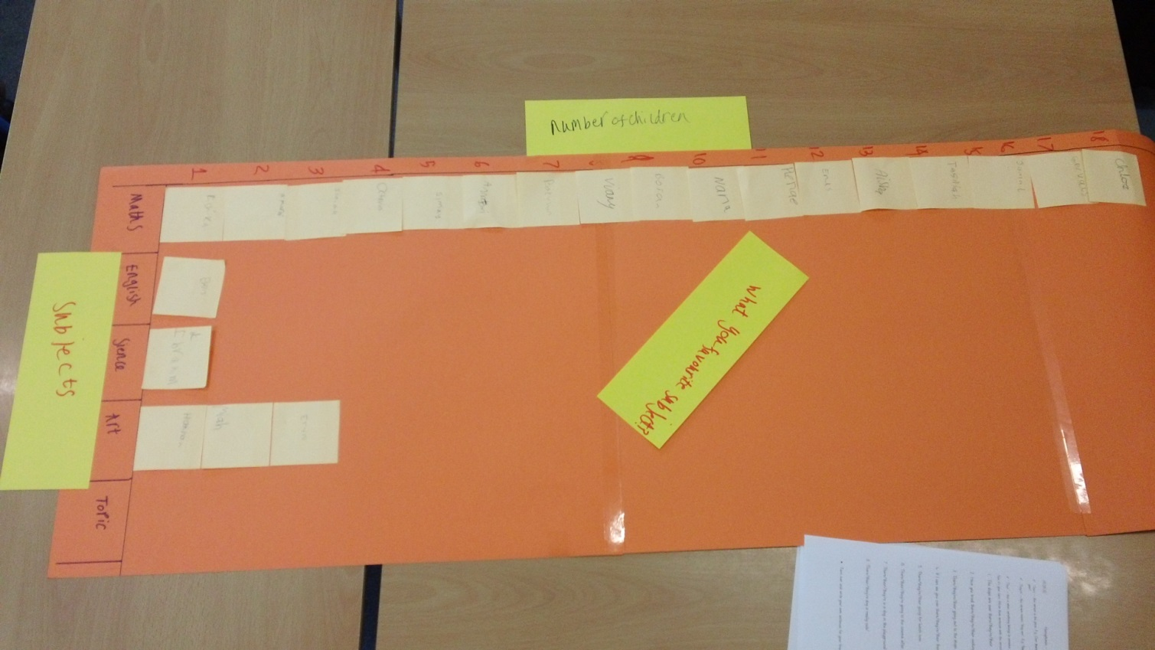

Simay
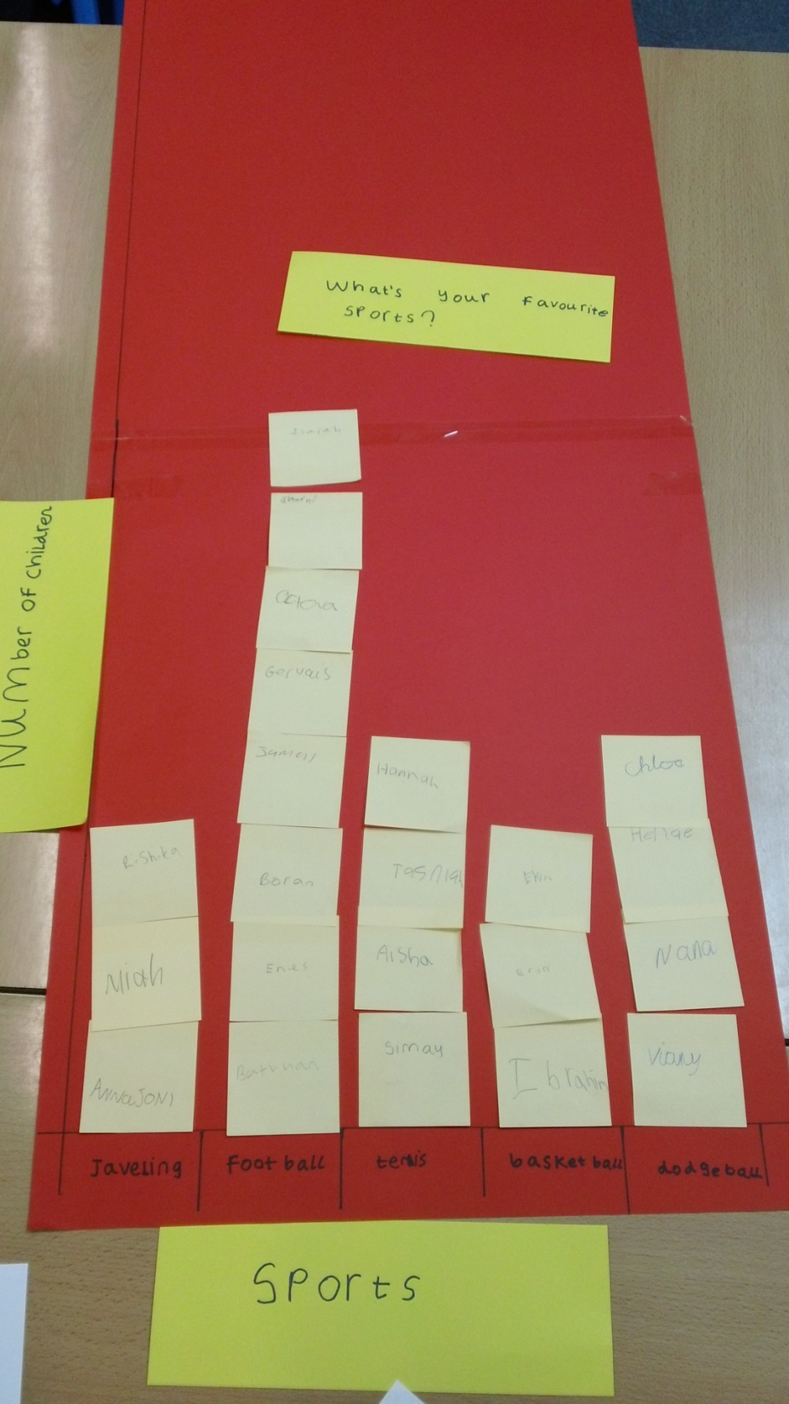
We wanted to know what the most popular sport was in our class. We labelled the axes ‘sports’ and ‘number of children’. The sports we chose were football, javelin, tennis, dodgeball and basketball. We found out that most of our class like football best and only 3 people liked javelin.

Boran

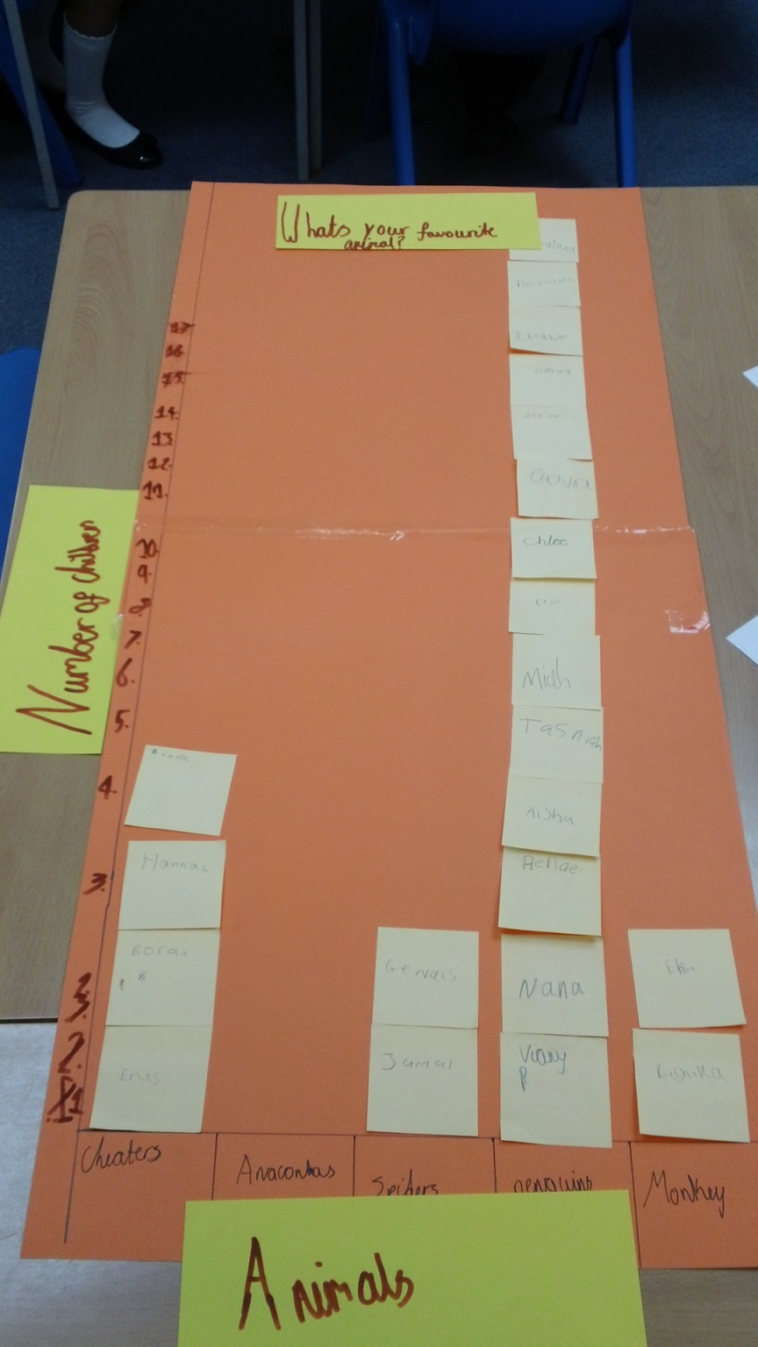
We wanted to know what animal our class liked best. We asked “What is your favourite animal?” The choices were anacondas, spiders, cheetahs, penguins and monkeys. None of our class liked anacondas. Most of our class liked penguins. We used sticky notes to complete each other’s block graphs.

Chloe
We found out which song our class liked the best. The choices were ‘Best Song Ever’, ‘Happy’, ‘Rude’, ‘Uptown Funk’ and ‘Roar’. The most popular song was Uptown Funk because 13 people liked it. The least popular song was Happy because no-one choose it. My group wrote questions about our data for our friends to answer.

