Basic info
COUNTRY POPULATION AREA (SQ KM) POPULATION PER SQ KM
Country A: 1 366 718 000 ÷ 9 596 961 142 people per sq km
Country B: 158 571 000 ÷ 143 998 1101 people per sq km
Country C: 138 740 000 ÷ 17 098 242 8 people per sq km
Country D: 61 017 000 ÷ 301 340 202 people per sq km
Country E: 21 767 000 ÷ 7 741 220 3 people per sq km
Country F: 21 284 000 ÷ 54 610 389 people per sq km
Country G: 4 692 000 ÷ 323 802 14 people per sq km
Country H: 3 536 000 ÷ 65 300 54 people per sq km
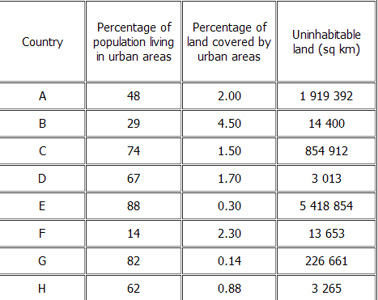

Considering uninhabitable land
Charlie
I think Charlie should go to live in country c as most of the area is urban which means more people will live there meaning there will be less than 1 people per sq km. This means he can be in peace and quiet.
Alison
I think Alison should go to country d as most of the people will live in towns or cities and most is towns and cities so there will be more people there.

Country A =1 people per sq km
Country B =122 people per sq km
Country C= 1 people per sq km
Country D=204 people per sq km
Country E = 9 people per sq km
Country F= 0.5 people per sq km
Country G=48 people per sq km
Country H= 57

