Nrich solution which scripts 774
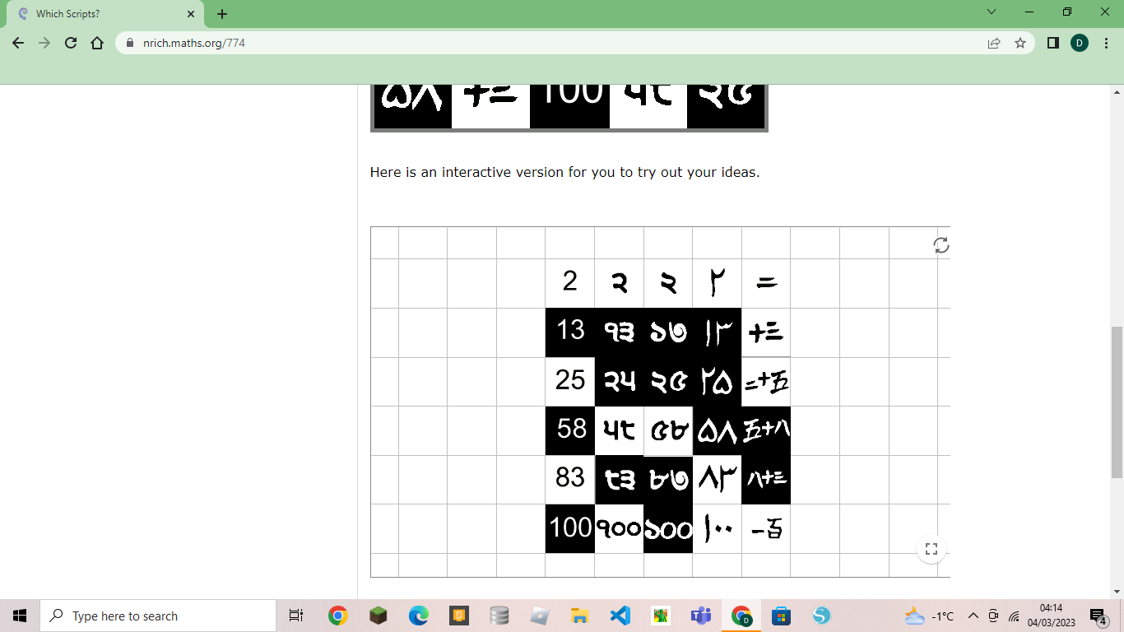
First, I separated these numbers into different groups based on their writing pattern.
Secondly, I knew numbers that were in English and Hindi because I am from India.
Thirdly, I arranged the numbers in ascending order.
Finally, for the first row in Chinese I took a guess for the first number and then linked it to find the other numbers.
Example: For the Chinese group I took a guess that the two lines were the number 2 and then found the same two lines in another number and so on. 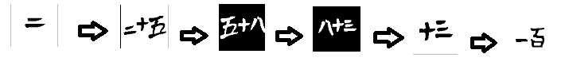
Then I arranged the numbers in ascending order.
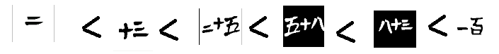
I followed the same strategy for the two scripts which were unknown to me.

