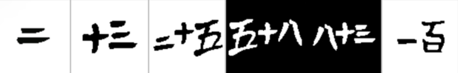
Firstly to solve this question we put all of the english number at the top and then we did all the hundreds but one and then we could figure out the 13 then 83 then 58 then 25 then 2 now, we just have one language to go:

Then suddenly we realised that = means two and from that we could figure out 25 then 58 then
83 then 13 and finally 100.
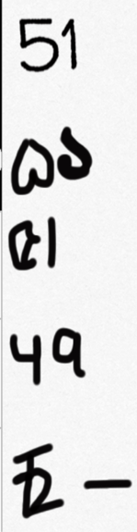
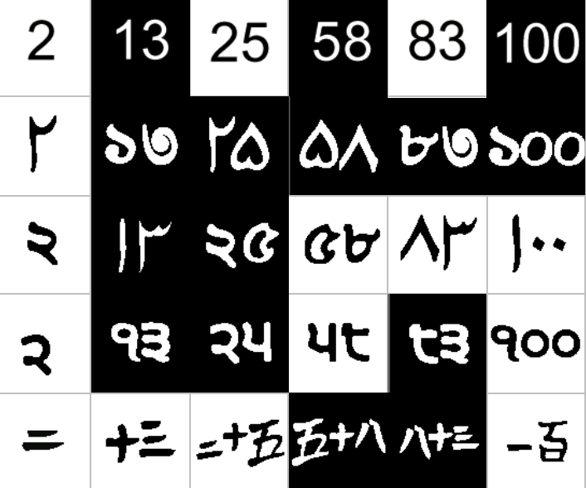
Now we need to complete the task, and write 51 in each language:

By Meriam, Sophia and Chloe

