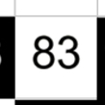
B0
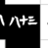
Upside down vr

T3
S00
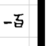
I..
900

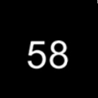

=
0b
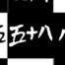
Upsidedown heart V
4t
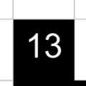
=
50
Ir
+ and 3 lines
93
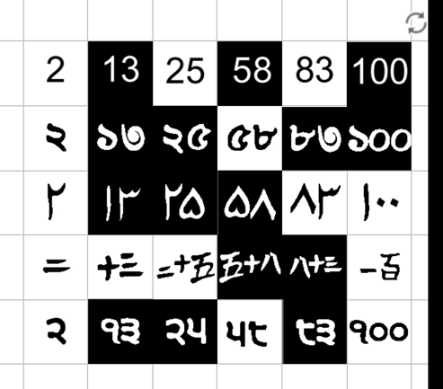
2=
The 2that slopes down more
r
T
The shorter 2

First I put all the regular numbers in order Then I looked for the same numbers like 100 And pair them together then I did the same with 58, 83, 25 and 2.

