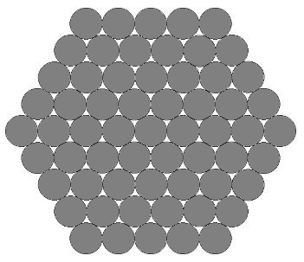
I divided the cable into rows.
When 5=n as in the diagram above…

Row 1 = n
Row 2 = n+1
I noticed at row ‘n’, the number of cables was n+(n-1). E.g. when n=5, row ‘n’ is row 5 and the number of cables was 5 +(5-1) which is 5+4, 9 or n+4
Row 3 = n+2
Row 4 = n+3
Row 5 = n+4
Row 6 = n+3
Row 7= n+2
Row 8 = n+1
Row 9 = n
When you increase n by 1, the number of rows increases by 2.

Number of Rows = 2n-1
When n=10 there are 19 rows
19/2 = 9.5 Middle row is 10.
Row 10 = n+ 9
Row 1 = 10
Row 2 = 11
Here, I worked out the number of strands in each row for when n=10. I could do this because I knew the number of rows was 2n-1 (20-1=19) and that and for the middle row (which in this case is 10), the number of strands would be n+(n-1).
Row 3 = 12
Row 4 = 13
Row 5 = 14
Row 6 = 15
Row 7 = 16
Row 8 = 17
Row 9 = 18
Row 10 = 19
Row 11 = 18
Row 12 = 17
Row 13 = 16
Row 14 = 15
Row 15 = 14
Row 16 = 13
Row 17 = 12
Row 18 = 11
Adding the number of cables on each row gives…
Row 19 = 10

10+11+12+13+14+15+16+17+18+19+18+17+16+15+14+13+12+11+10= 271

A size 10 cable needs 271 strands.

n | Strands | Difference | Difference of Differences
1 | 1 | 6 | 6
2 | 7 | 12 | 6
3 | 19 | 18 | 6
4 | 37 | 24 | 6
5 | 61 | 30 | 6
6 | 91 | 36 | 6
7 | 127 | 42 | 6
8 | 169 | 48 | 6
9 | 217 | 54 | 6
10 | 271

Rows= 2n-1
By trial and error I noticed this…
(1x0)+1=1
(2x3)+1 = 7
(3x6)+1= 19
(4x9)+1= 37
(5x12) +1 = 61

$$n\left(3\left(n-1\right)\right)+1$$
$$n\left(3n-3\right)+1$$
$${3n}^{2}-3n+1$$
Therefore, number of strands for size n cable =${3n}^{2}-3n+1$

Examples
When n=5
5x5= 25
3x25=75
75-15+1=61 which is correct as the question states that this is true.

AND

10x10= 100
3x100=300
300-30+1=271

