Steel Cables
I divided the hexagon into 2 trapeziums like the picture shows
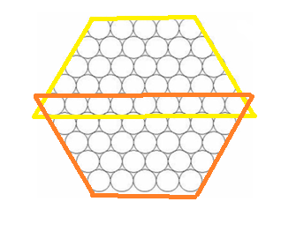
I then assumed that 1 circle represented 1 unit and calculated the area of both the trapeziums using the formula 2*(h (N + b)/2). I then proceeded to subtract the result by ‘b’ as it was added twice. So the final equation was h (N + b)-b. So ‘N’ would be the size of the cable, b would be 2N-1 and h would again be the size of the cable as it represents the height.
So in a size 10 cable, ‘N’ would be 10, ‘b’ would be 19 and ‘h’ would be 10. Inserting these values into our formula, we get 10(29)-19= 271.
To verify, I developed a slightly similar method, but this was without using the formula for the area of a trapezium. I again divided the hexagon into 2 trapezium and noticed that there would be N rows in each trapezium wherein, consecutive rows will have one more strand than the previous one. Therefore, the total number of strands would be (N, N+1, N+2, N+3 .......N + (N-1)). Then I proceeded to simplify this using the formula used to find the sum of consecutive numbers.
Sum of consecutive numbers= (x / 2)(first number + last number) So the value of “x” here would be the value on “N” as it stands for the number of terms we are summing up. Substituting ‘N’ into this formula will give us (N/2)(3N-1).
Since we have 2 trapeziums, we will multiply this by 2 and subtract the (2N-1) from the result as it is common between the two trapeziums.
This gives us a final formula of N(3N-1) – (2N-1). Substituting for N, I got 10(29)-19=271 which was the same result I got earlier.
Therefore the number of strands needed can be given by the formula N(3N-1) – (2N-1), where ‘N’ is the size of the cable.
Personally, my favourite approach was the group 2 diagram. I felt it allowed us to represent the number of strands required in an algebraic way, which quite simplified the process of finding a general formula which could be easily extended for any cable size.

