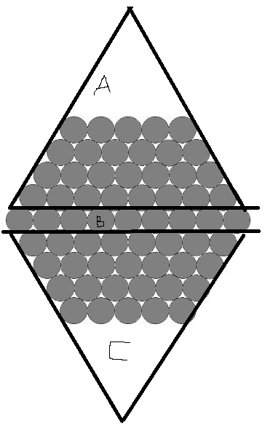
A mount of cables in a size n hexagon.
The middle row (b) can be expressed as 2n-1.
The other bits (a, c) can be expressed as 2 triangles- the smaller empty triangle at the top. These combined can be expressed as
$$2\left(\left(n-1\right)\left(n-1\right)\right)-2\left(n-1\right)\left(2n-1\right)$$
Making a+b+c= 3n²-3n+1

