Nrich solution for Two and Two
This task was given as homework in Ganit Kreeda, Vicharvatika, India and here is an amazing solution submitted by Kanaa who is just 7 year and 11 months old. 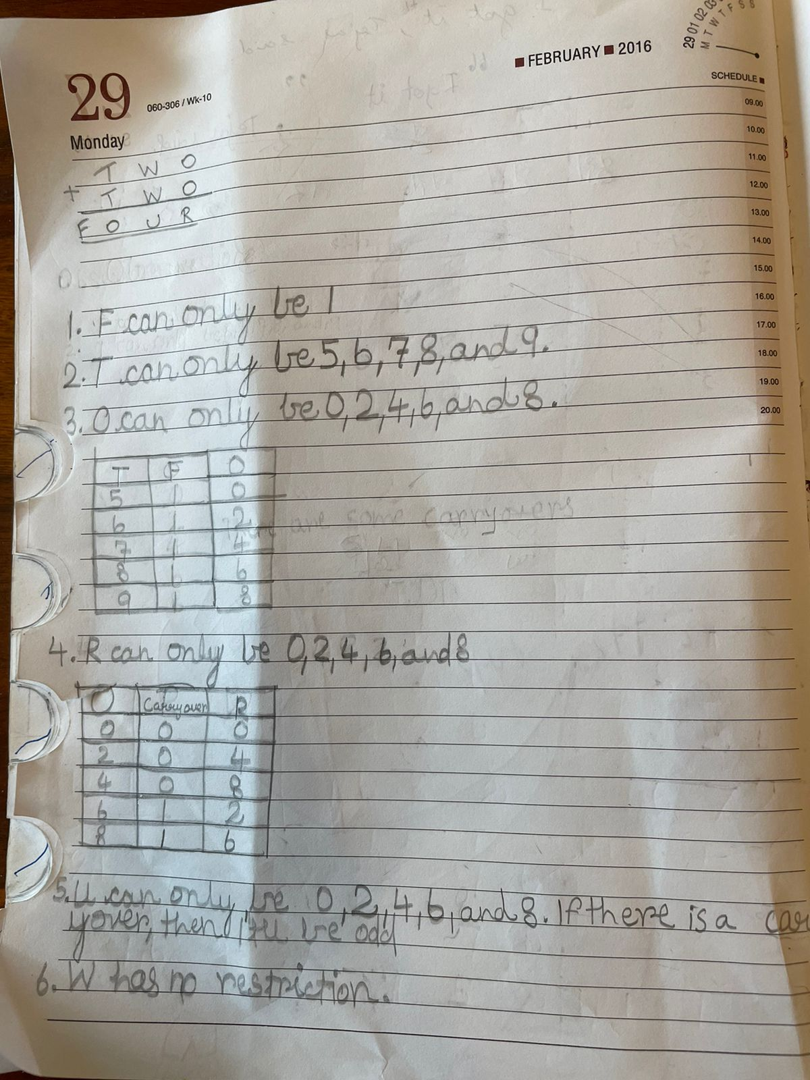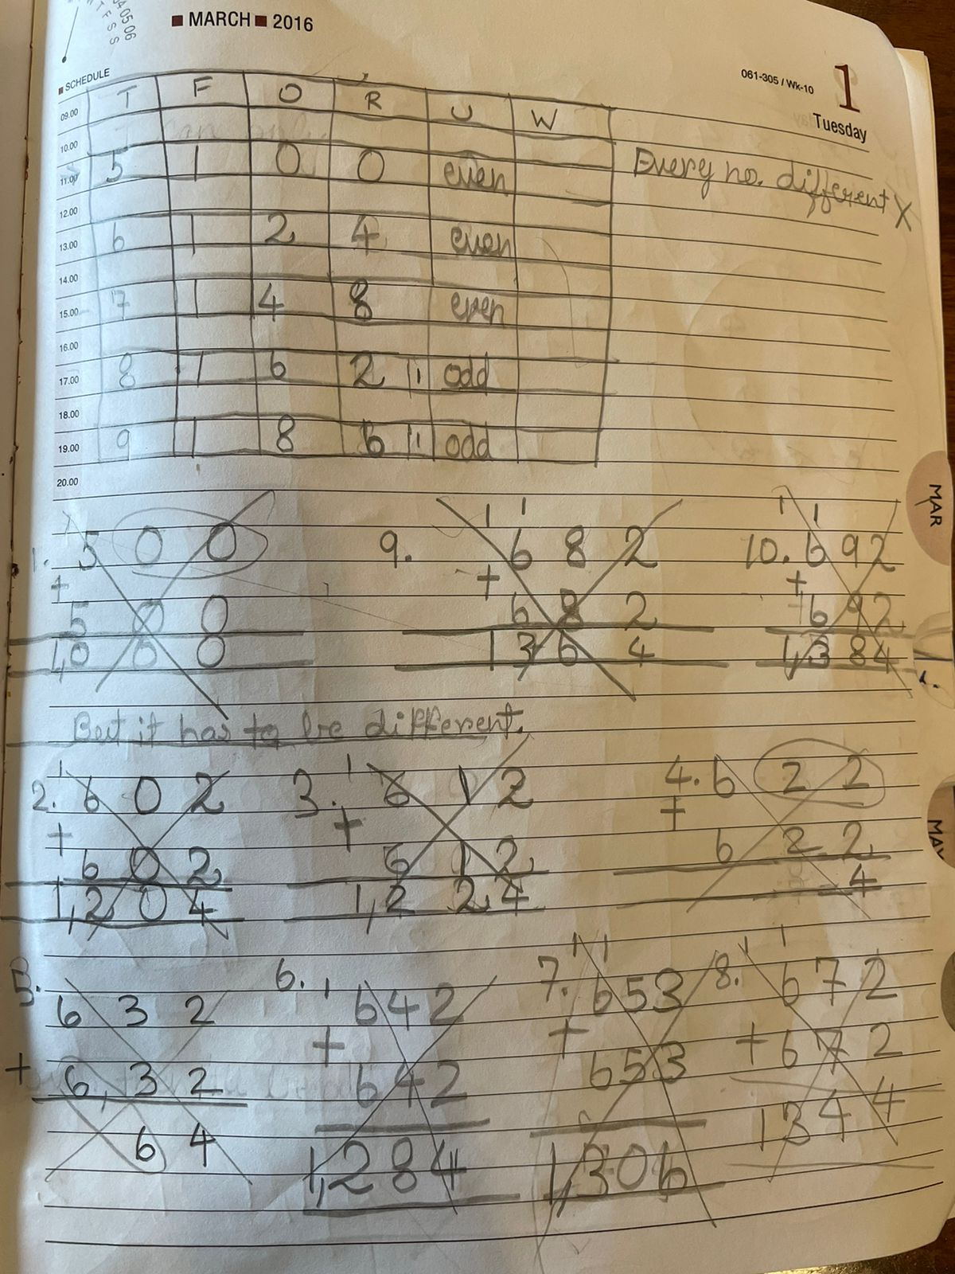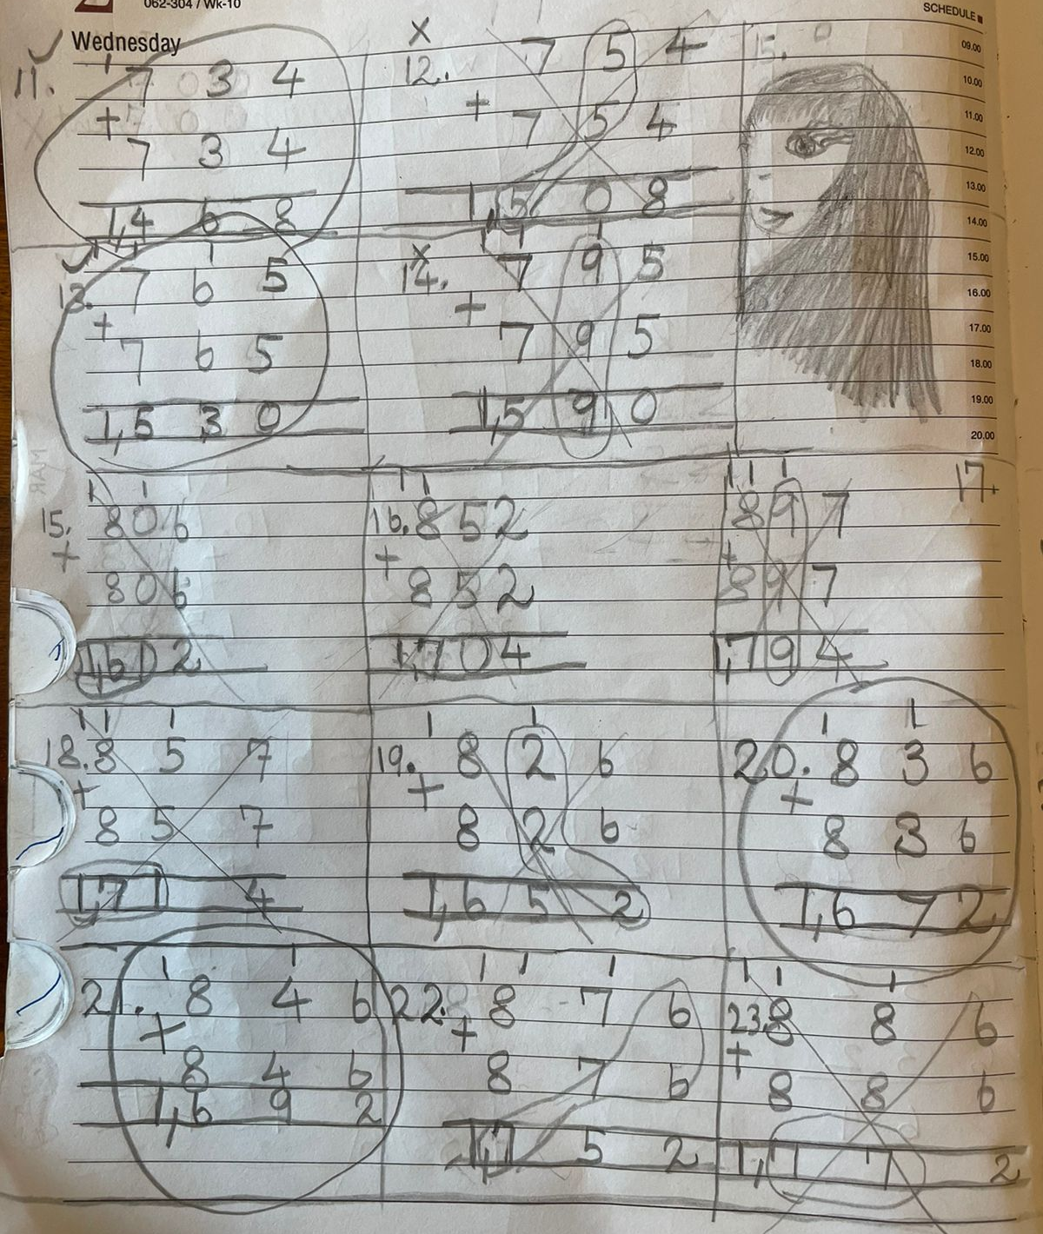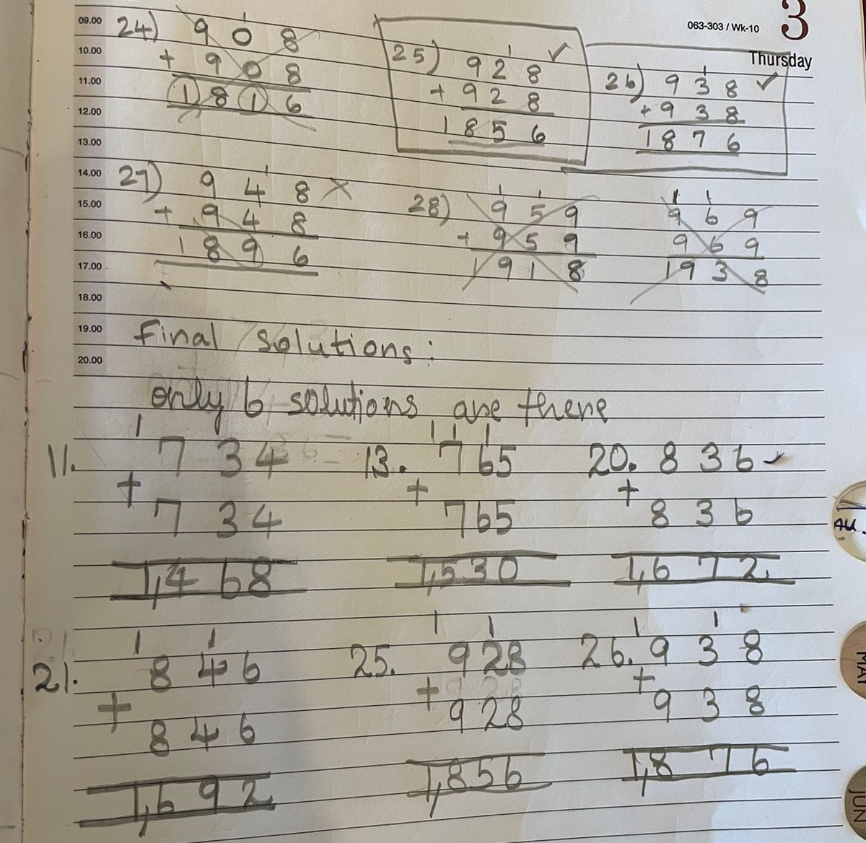
Before checking her work, myself Shubhangee worked on it independently. Then I compared my work and solutions with Kanaa and here is my work.

Clearly, two 3-digit number’s sum is 4-digit means hundredth’s place is generating one carryover.
So, F=1.
O can’t be 0, as 0+0=0 and O and R cannot be both 0.
O can take values from 1,2,3,4,5,6,7,8,9.
I first explored all even values for O and then all odd values.
If O is even, ten’s place cannot generate any carry over as T+T = O.
So, W can either be 2,3 or 4.
T is decided by O.

If O is odd, ten’s place must generate carry over as T+T = O and O is odd.
So, W can either be 6/7/8 (5 & 9 won’t work). For each value of O, I plug in all values of W to check.

F | O | R | T | W | U | Comment
1 | 2 | 4 | 6 | No value |  | Not Possible
 | 4 | 8 | 7 | 3 | 6 | 1 solution
 | 6 | 2 | 8 | 3/4 | 7/9 | 2 solutions
 | 8 | 6 | 9 | 2/3 | 5/7 | 2 solutions
 | 3 | 6 | 6 |  |  | Not Possible
 | 5 | 0 | 7 | 6 | 3 | 1 solution
 | 7 | 4 | 8 | 6 | 3 | 1 solution
 | 9 | 8 | 9 |  |  | Not Possible

Here are 7 solutions that I found:

Last solution is not covered by Kanaa.

