Nrich Solution for Two and Two (Sat Batch)

This task of Two and Two was taken for 2 sessions with a group of 15 students in Ganit Kreeda, Vicharvatika, India by Shubhangee(facilitator).

The names of the students are:
Ahana, Ananthajith, Dhruv, Sehar, Saanvi, Nikhil, Insiya, Inaaya, Ishaan, Ishanvi, Sanat, Abhay, Karthik, Vishnuvardhan, Rudra

Kids together found out that:
ONE + TWO = THREE
Not possible, as two 3-digit numbers’ sum cannot be 5-digit.
ONE + THREE = FOUR
Not possible as one 3-digit number and one 5-digit number cannot be added to get 4-digit sum.

Karthik created one problem as a solution to:
Can you create other similar cryptarithms?

FOUR 8532
+FOUR +8532
_______ _______
EIGHT 17064

R=2, T=4, U=3, H=6, O=5, G=0, E=1, F=8, I=7

While experimenting with numbers, Vishnuvardhan realized that any addition problem can be converted as a subtraction problem in 2-ways.
TWO – ONE = ONE,
NINE - FOUR = FIVE,
NINE - FIVE = FOUR

Kids shared different observations for
TWO
+TWO
______
FOUR
        - R is always even, as R= O+O.
        - O cannot be equal to 0/1/9.
        - F is always equal to 1.
Ahana, Karthik and Inayaa worked on this in a breakout room to find all possible solutions along with the reason. Here is Ahana’s work:

Ahana’s work: 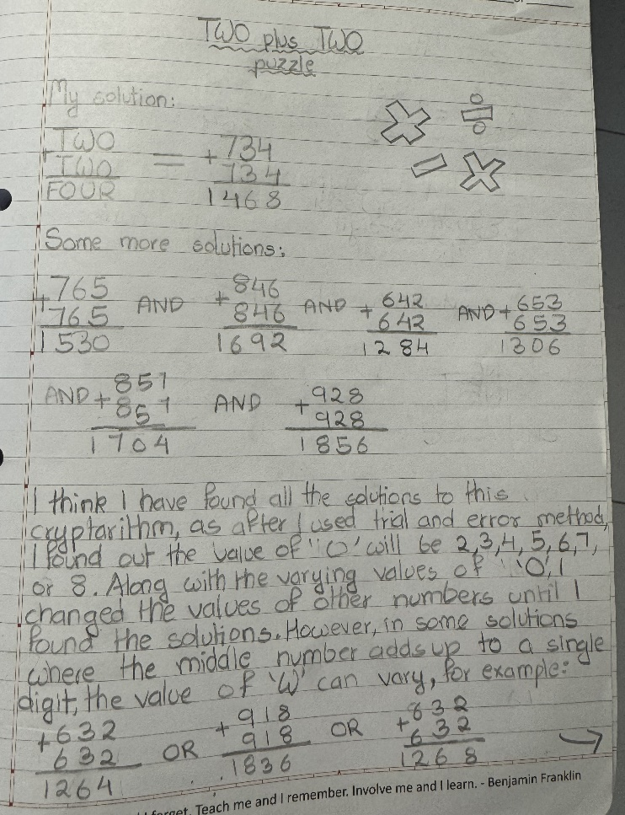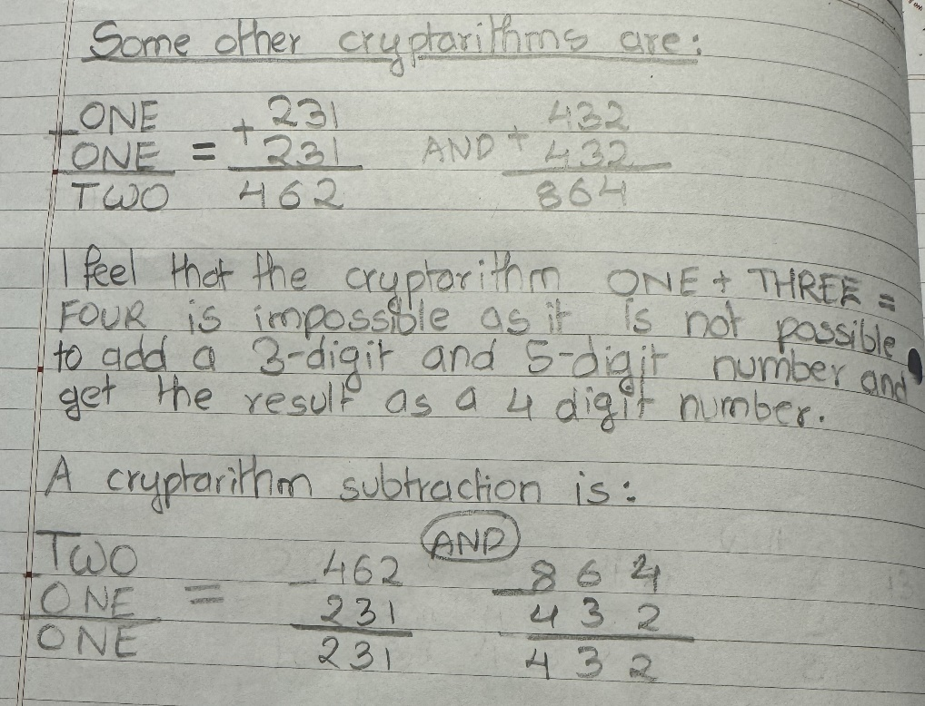
Abhay says that for TWO + TWO = FOUR….
The problem suggests that the addends have to be the same and above 500 and the ones digit of the addend and the hundredth digit of the sum have to be the same so I tried a trial and error method.

Anathajith, Sehar, Dhruv and Saanvi worked together and their work is summarized by Sehar here.

Here is Sehar’s Work for ONE + ONE =TWO

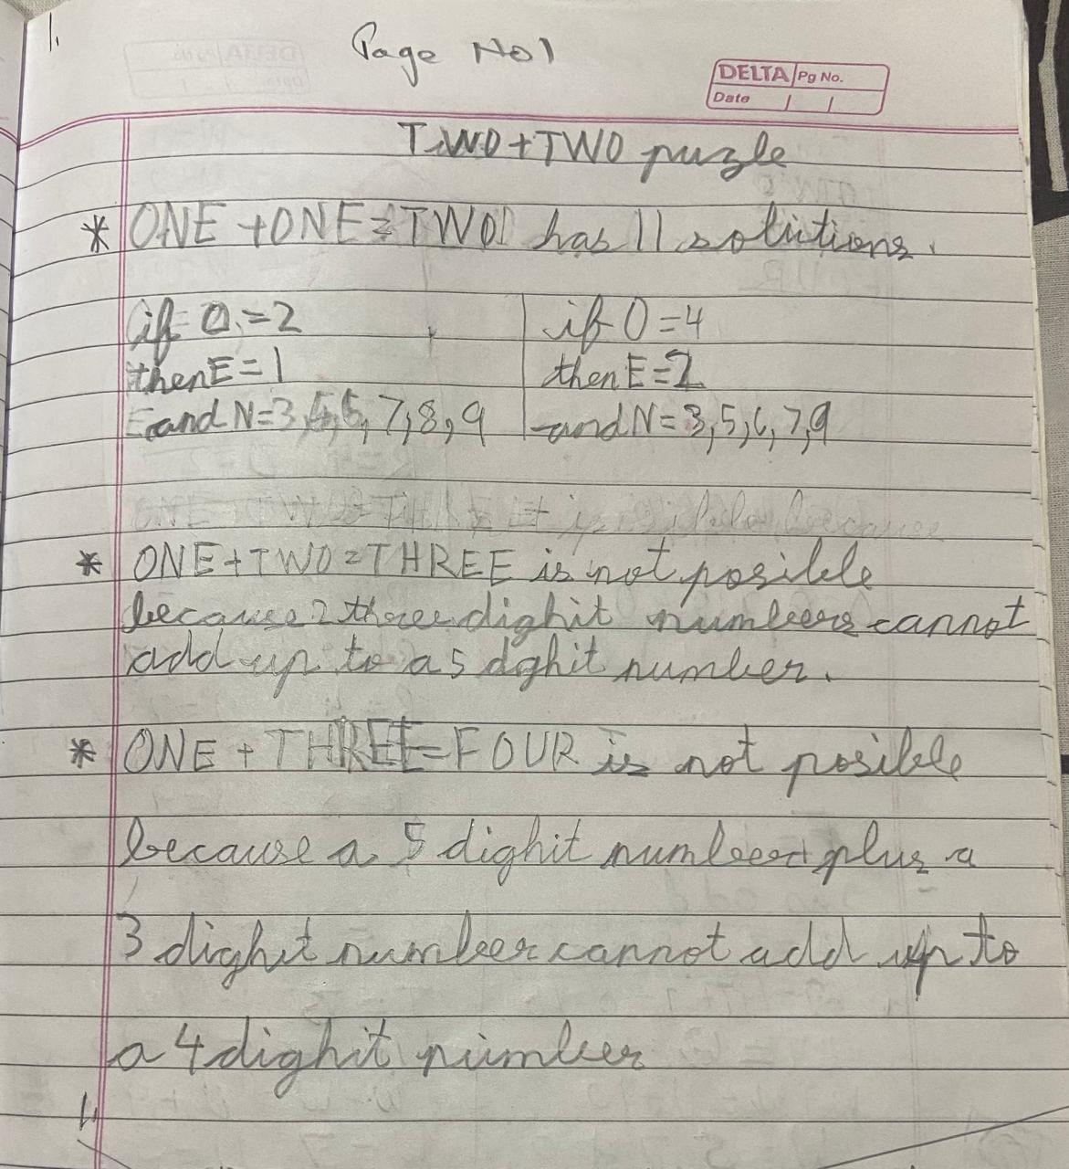

Here is Sehar’s Work for TWO + TWO = FOUR

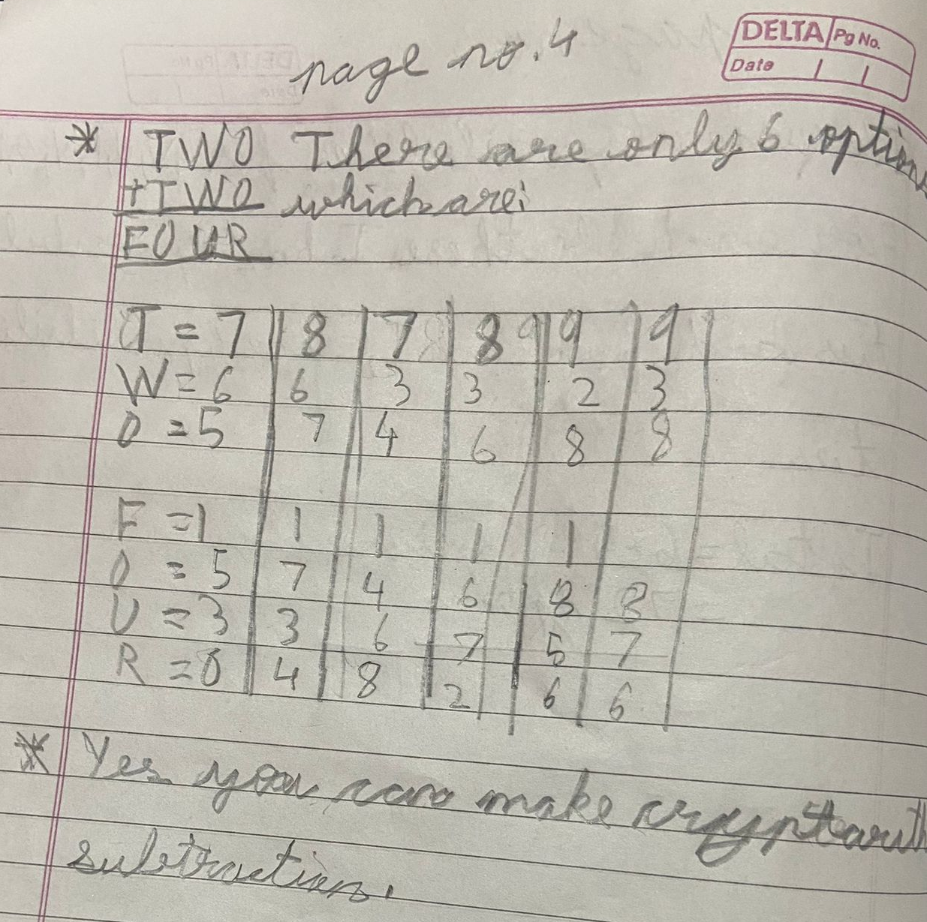

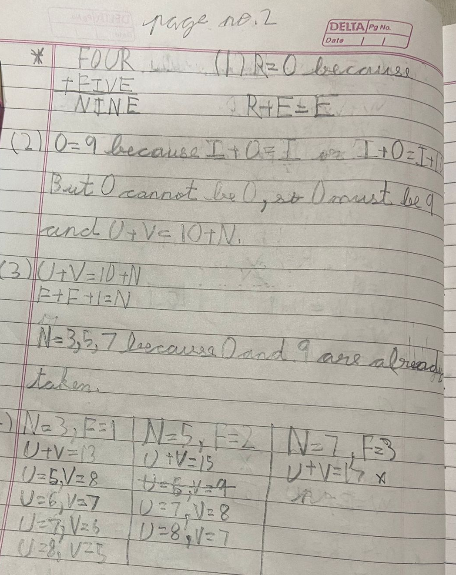
This is Sehar’s reasoning for FOUR + FIVE = NINE

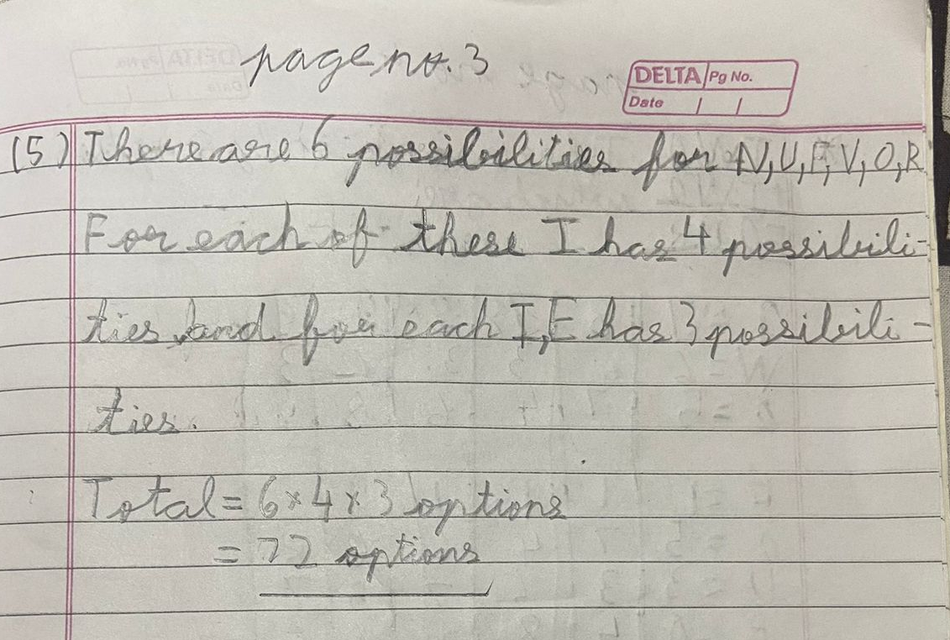

Kids used Sehar’s reasoning and found out all possible solutions for:
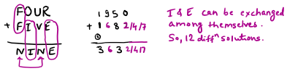
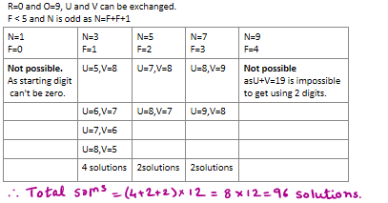

Shubhangee found one new Cryptarithm problem as:
