Nrich Solution for Two and Two (Thursday Batch)

This task of Two and Two was taken for 2 sessions with a group of 17 students in Ganit Kreeda, Vicharvatika, India by Shubhangee(facilitator).

The names of the students are:
Kanaa, Ruhi, Kimaya, Ananya, Aarav, Shravani, Pushan, Ishan, Adithya, Avyukth, Mrunmayee, Shivashree, Shreehari, Aniket, Anirudh and Vikrant.

Kids together found out that:
ONE + TWO = THREE
Not possible, as two 3-digit numbers’ sum cannot be 5-digit.
ONE + THREE = FOUR
Not possible as one 3-digit number and one 5-digit number cannot be added to get 4-digit sum.

Kids shared different observations for:
ONE + ONE = TWO.
O has to be even and O can’t be 0, as O = E + E.
O has to be smaller than 5 as O + O = T and there can’t be any carry over.
This means O can only be 2 or 4.
Kids then systematically worked by changing the values for O and found out 16 solutions as shown.
O | 2 | 4
E | 1 or 6 | 2 or 7

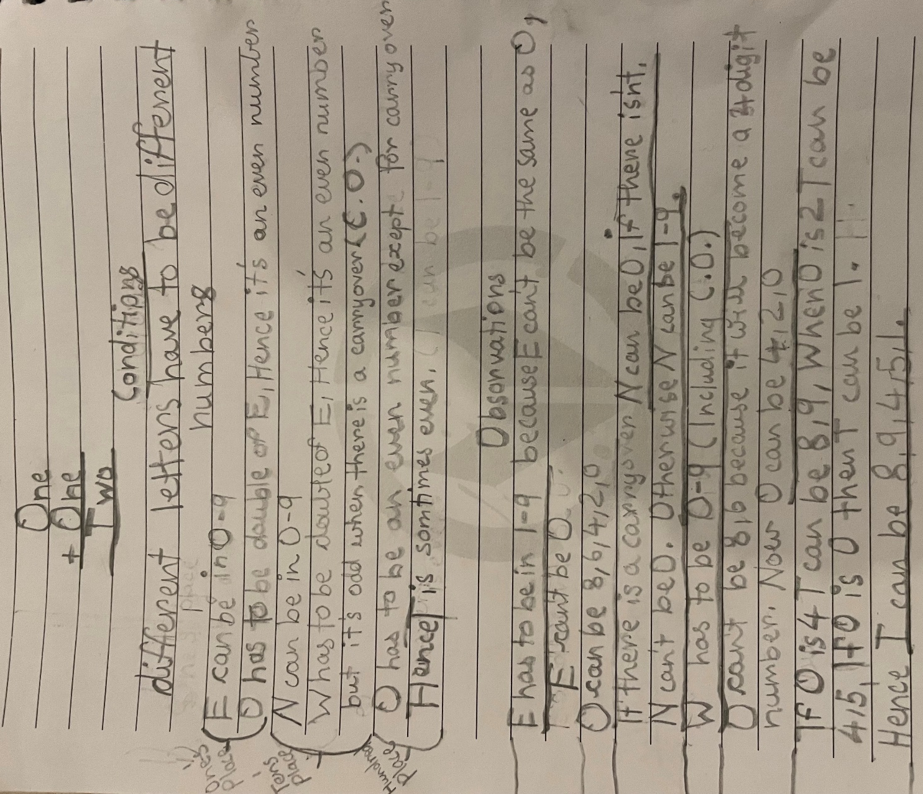

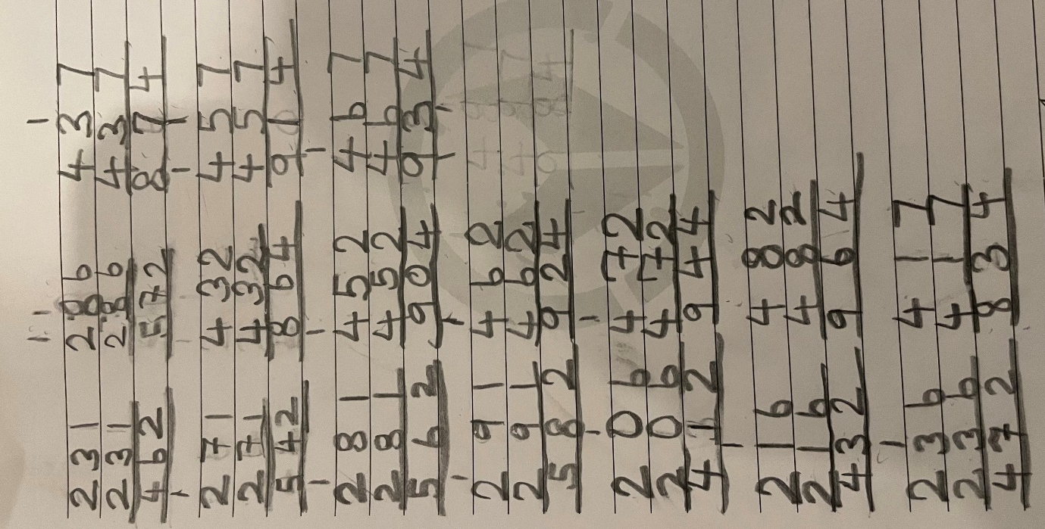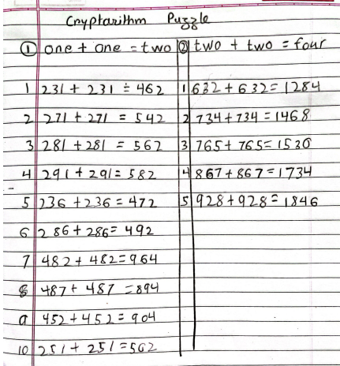
- Adithya’s explanation for ONE + ONE = TWO:

- I first wrote down the same digit in all the ‘O’s. Then,as ‘F’ can only be 1, I wrote that down. Then I found a number that when taken 2 times is equal to ‘FO’. Then depending on Whether carryover is needed or not I found out ‘W’.

