Nrich Solution for TWO and TWO

Myself, Shubhangee, had worked in Ganit Kreeda, Vicharvatika, India with 14 kids,
Tejas, Ruhi, Valerie, Mithravinda, Kabir, Akshobhyan, Nithya, Deethya, Uday, Udit, Kashvi, Swathi, Arnav, Samarth;
of 4th to 6th grades on Two and Two task.

All the kids collaboratively worked on this puzzle.

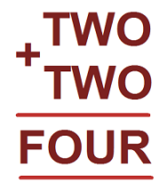

We started systematically and found 7 solutions.

Akshobhyan noticed that two 3-digit number’s sum is 4-digit means hundredth’s place is generating one carryover. That means

T is greater than 4, or T = 5 /6 /7 /8 /9
And F=1.
O can’t be 0, as 0+0=0 and O and R cannot be both 0.
R can only be even. So, R can be either 2,4,6 or 8.

Kids started systematically by changing values of O.
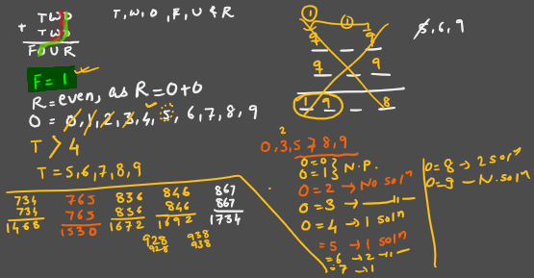

Mithravinda’s solution

