Exploring Cubic Functions
In the first graph, I noticed that the graph always intersected at the origin. The other two intersections were at a particular integer and its respective conjugate. So the roots were $α,-α and 0.$ I could then use this to figure out the function. I noticed that as the coefficient of ‘x’ decreased, the distance between the peaks of the curve from the x axis seemed to increase.

Comparing the two families of equations, I noticed that both of them always intersected the x axis at 3 distinct places. When either of them was substituted into the function, it gave a result of 0(as ‘y’ is always zero at the x-axis). I also observed that if a line were drawn parallel to the x-axis through the y intercept, the distance from either of the vertices to the line was equal. In the second family of equations, as the constant increased the graph elevated higher up. The constant was also multiples of the constants in the brackets.

To figure out the equations, I first figured the roots by looking at the x intersections of the graph:
- 3distinct roots (1 negative & 2 positive) | 3 | $$(x+1)(x-2)(x-6)$$
- 1negative root | 1 | $$\left(x+4\right)(x^{2}-2x+3)$$
- 1 positive root | 4 | $$\left(x-4\right)(x^{2}+x+3)$$
- 2 distinct roots (1 negative & 2 positive) | 6 | $$(x-2)(x-2)(x+3)$$
- 3 distinct roots(2 negative & 1 positive) | 2 | $$(x+3)(x+2)(x-2)$$
- 2 distinct roots(2 negative & 1 positive) | 5 | $$(x-3)(x+2)(x+2)$$

The first equation clearly increases with the value of x, so the graph will start from the bottom and move to the top. The second graph increases when the value of x decreases, so the graph starts from the top and moves to the bottom.
Substituting x=-6 into the first equation I get the coordinate pair (-6, -2). This point is seen in the second graph from the left (in the website’s illustration). So that must be the graph satisfying the equation. Since all the graphs that increase with the x coordinate is just the graph $y={(x+6)}^{3} -2$ transposed along the x & y axes, we can determine the other equations by adding numbers to the x and y components of the equation. The numbers we are adding/subtracting depends on the number of x &y coordinates the graph has shifted. Consecutive graphs increase 1 unit along the y axis and 3 units along the x axis.
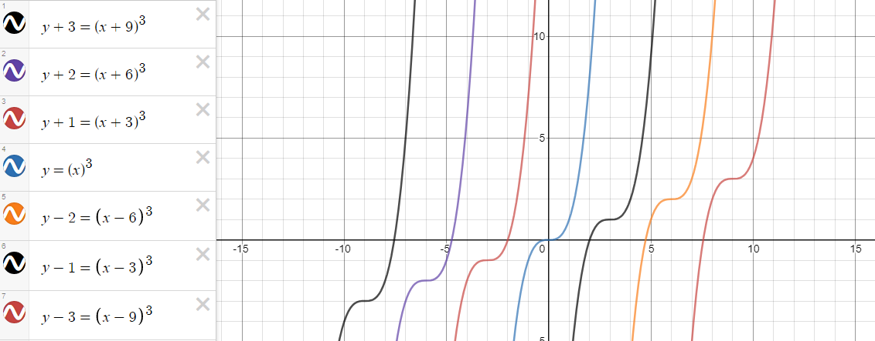
The other set of 7 graphs are just the inverse of the above graphs so they would share the same y coordinates but their x coordinates would differ.
