Three Neighbours

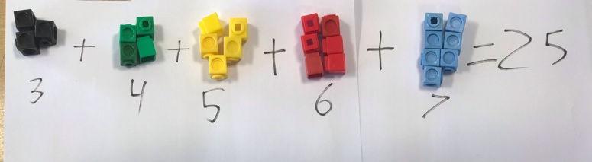
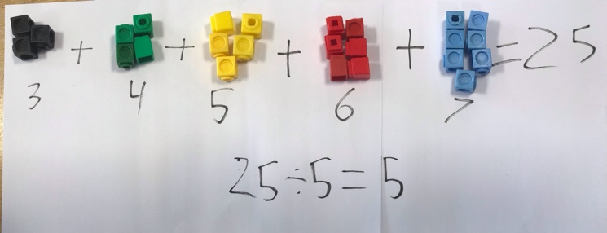
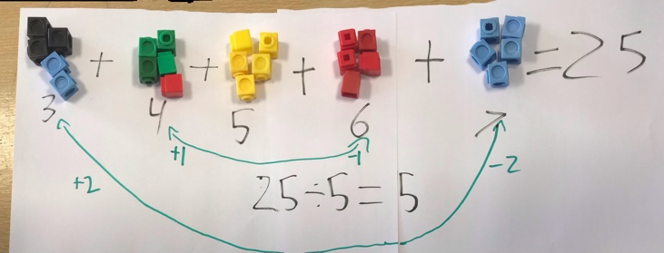
If you take 5 consecutive numbers and add them up, the sum will always be a multiple of 5. Take for example, I took the numbers 3, 4, 5, 6 and 7. The sum is 25 and 25 is a multiple of 5. If you take the sum and divide it by the number of numbers there are which will be 5, the answer will always equal the number in the middle. 25 divided by 5 is 5 which is the middle number. This will be always true because if you take 2 from the biggest number and put it on the smallest number, then take the second biggest number, take one from it and put it on the second smallest number, you will have 5 groups of the same number as the middle one. In my example you will end up with 5 groups of 5 which is 25. So the sum divided by how many numbers there are, will always equal the middle numbers.

With this knowledge, I know that (13,111 + 13,112 + 13,113 + 13,114 + 13,115)divided by 5 is 13,113.

Using this theory I also predict that:

(8+9+10+11+12+13+14) divided by 7 = 11
(12 + 13 + 14) divided by 3 is 13

By

Ronaldo Widianto

