My Angle Solution

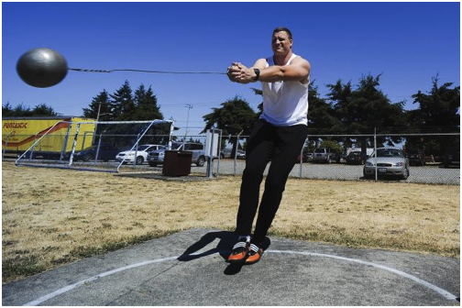

90° Because the hammer is a right-angle in relation to the man’s body, which is a 90° angle.

