My Angle Solution

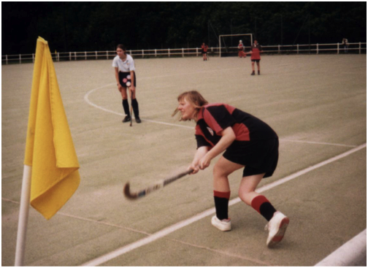

100° As it is lower down than 90° but not too low.

