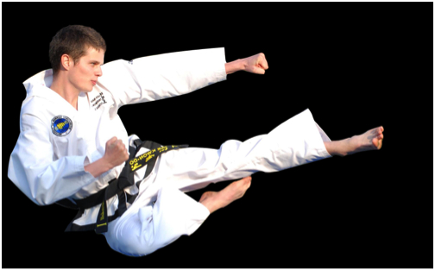
In this picture the man has just jumped to do his kick, his body is not completely straight at a 180 degree and but a bit below it so my guess is that he is at an 170 degree angle

