Judo Angles
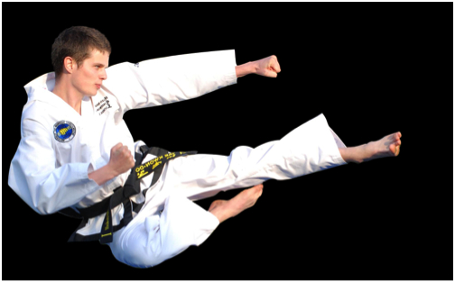
The person jumping has to jump up 90 degrees to get the straight kick in mid-air then the angle decreases as he lands, when he does that the angle goes down from 90 degrees and ends up at standing up straight.

