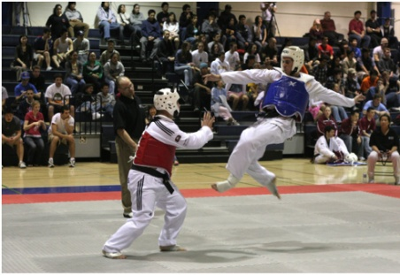
The blue person has jumped and made a 45 degree angle then he will swing his right leg up wards at a 35 degree angle and kick the red person in the face (that is if the red person does not block the blue person’s leg, because the red person’s arms are in position to block the blue person leg).The blue persons arms must have swung round at a 90 degree angle to deliver lots of power.

