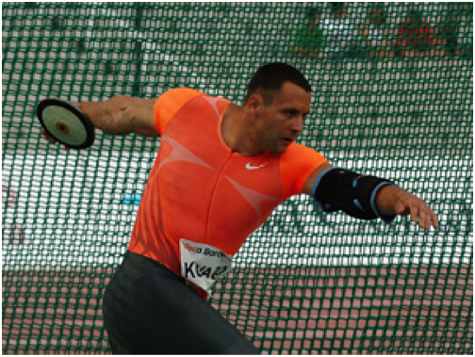
Enter your solution here: I think athletes use angles to help them because with the discus you need to spin 360 degrees and then you have to let go at an 45 degree angle because it needs to how long and you need to go from low to high.

