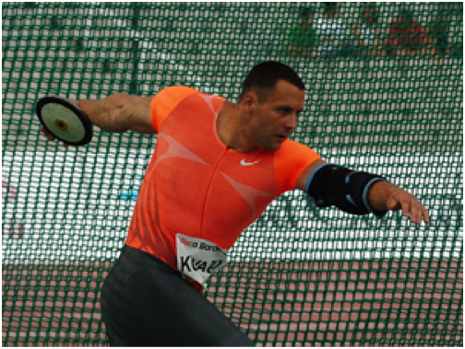
This event is the discus he is using his hand to aim and angle his shot.
He twists his hips extra power he puts his foot forward for weight transfer.
Estimated angle 45 degrees.

