Jamie Barden
My solution in diving
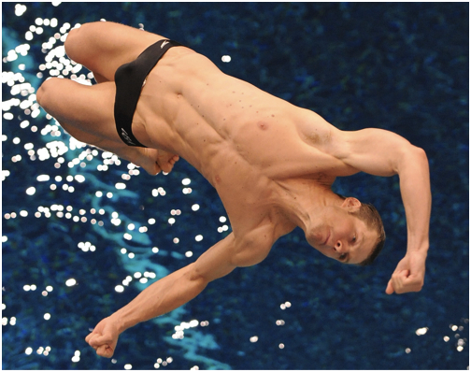
At the start of the of the dive he is at 90 degrees because he is standing up at 90 degrees. He dives of the board he changes degrees as he jumps off the board he comes to a 135 degrees angle. Then he has to do a 360 degrees turn then enters the swimming pool at a 45 degrees angle the starter the angle is the more points he will be able to get but for this he has to get the 135 degrees angle to be able to get into the flip and get the perfect 45 degrees angle. It take a lot of skill to be able to perfect this fluid motion which is why top divers have years of practise to perfect the dive.

