My Solution
By David Blair

Estimation of 135 degrees answer was 130 degrees
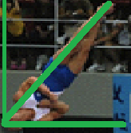
90 degrees

180 degrees

I came to this conclusion threw the use of estimation to give me a rough idea then using a protractor to give me an accurate result.

